IB Physics Syllabus overview and dissection

Core |  | hours |  |  |  | Additional higher level (AHL) |  | hours
Topic 1: Measurements and uncertainties |  | 5 |  |  |  | Topic 9: Wave phenomena |  | 17
 | 1.1 Measurements in physics |  | 1 |  |  |  | 9.1 Simple harmonic motion |  | 26
 | 1.2 Uncertainties and errors |  | 2 |  |  |  | 9.2 Single-slit diffraction |  | 27
 | 1.3 Vectors and scalars |  | 3 |  |  |  | 9.3 Interference |  | 28
Topic 2: Mechanics |  | 22 |  |  |  |  | 9.4 Resolution |  | 29
 | 2.1 Motion |  | 4 |  |  |  | 9.5 Doppler effect |  | 30
 | 2.2 Forces |  | 5 |  |  | Topic 10: Fields |  | 11
 | 2.3 Work, energy and power |  | 6 |  |  |  | 10.1 Describing fields |  | 31
 | 2.4 Momentum and impulse |  | 7 |  |  |  | 10.2 Fields at work |  | 32
Topic 3: Thermal physics |  | 11 |  |  |  | Topic 11: Electromagnetic induction |  | 16
 | 3.1 Thermal concepts |  | 8 |  |  |  | 11.1 Electromagnetic induction |  | 33
 | 3.2 Modelling a gas |  | 9 |  |  |  | 11.2 Power generation and transmission |  | 34
Topic 4: Waves |  | 15 |  |  |  |  | 11.3 Capacitance |  | 35
 | 4.1 Oscillations |  | 10 |  |  | Topic 12: Quantum and nuclear physics |  | 16
 | 4.2 Travelling Waves |  | 11 |  |  |  | 12.1 The interaction of matter with radiation |  | 36
 | 4.3 Wave characteristics |  | 12 |  |  |  | 12.2 Nuclear physics |  | 37
 | 4.4 Wave behaviour |  | 13
 | 4.5 Standing waves |  | 14
Topic 5: Electricity and magnetism |  | 15 |  |  |  | Options |  | hours
 | 5.1 Electric fields |  | 15 |  |  | A: Relativity
 | 5.2 Heating effects of electric currents |  | 16 |  |  |  | A.1 The beginning of relativity |  | 38
 | 5.3 Electric cells |  | 17 |  |  |  | A.2 Lorentz transformations |  | 39
 | 5.4 Magnetic effects of electric currents |  | 18 |  |  |  | A.3 Spacetime diagrams |  | 40
Topic 6: Circular motion and gravitation |  | 5 |  |  |  |  | A.4 Relativistic mechanics (HL only) |  | 41
 | 6.1 Circular motion |  | 19 |  |  |  | A.5 General relativity (HL only) |  | 42
 | 6.2 Newton's law of gravitation |  | 20 |  |  | B: Engineering physics
Topic 7: Atomar, nuclear and particle physics |  | 14 |  |  |  |  | B.1 Rigid bodies and rotational dynamics |  | 43
 | 7.1 Discrete energy and radioactivity |  | 21 |  |  |  | B.2 Thermodynamics |  | 44
 | 7.2 Nuclear reactions |  | 22 |  |  |  | B.3 Fluids and fluid dynamics (HL only) |  | 45
 | 7.3 The structure of matter |  | 23 |  |  |  | B.4 Forced vibrations and resonance (HL only) |  | 46
Topic 8: Energy production |  | 8 |  |  |  | C: Imaging
 | 8.1 Energy sources |  | 24 |  |  |  | C.1 Introduction to imaging |  | 47
 | 8.2 Thermal energy transfer |  | 25 |  |  |  | C.2 Imaging instrumentation |  | 48
 |  |  |  |  |  |  | C.3 Fibre optics |  | 49
 |  |  |  |  |  |  | C.4 Medical imaging (HL only) |  | 50
 |  |  |  |  |  | D: Astrophysics |  | 15
 |  |  |  |  |  |  | D.1 Stellar quantities |  | 51
 |  |  |  |  |  |  | D.2 Stellar characteristics and stellar evolution |  | 52
 |  |  |  |  |  |  | D.3 Cosmology |  | 53
 |  |  |  |  |  |  | D.4 Stellar processes (HL only) | 10 | 54
 |  |  |  |  |  |  | D.5 Further cosmology (HL only) |  | 55
Last edit: 2018/10/01

Contents
Topic 1: Measurements and uncertainties 1
Topic 2: Mechanics 4
Topic 3: Thermal physcis 8
Topic 4: Waves 10
Topic 5:Electricity and magnetism 15
Topic 6: Circular motion and gravitation 19
Topic 7: Atomar, nuclear and partice physics 21
Topic 8: Energy production 24
Topic 9: Wave phenomena 26
Topic 10: Fields 31
Topic 11: Electromagnetic induction 33
Topic 12: Quantum and nuclear physics 36
Option A: Relativity 38
Option B: Engineering physics 43
Option C: Imaging 47
Option D: Astrophysics 51

Topic 1: Measurement and uncertainties (5 hours)
Syllabus dissection

Essential idea: Since 1948, the Système International d’Unités (SI) has been used as the preferred language of science and technology across the globe and reflects current best measurement practice.

  - – Measurements in physics

Nature of science:
Common terminology: Since the 18th century, scientists have sought to establish common systems of measurements to facilitate international collaboration across science disciplines and ensure replication and comparability of experimental findings. (1.6)
Improvement in instrumentation: An improvement in apparatus and instrumentation, such as using the transition of cesium-133 atoms for atomic clocks, has led to more refined definitions of standard units. (1.8)
Certainty: Although scientists are perceived as working towards finding “exact” answers, the unavoidable uncertainty in any measurement always exists. (3.6)

Topic 1: Measurements and uncertainties
Understandings:  • Fundamental and derived SI units  • Scientific notation and metric multipliers  • Significant figures  • Orders of magnitude  • Estimation  Applications and skills:  • Using SI units in the correct format for all required measurements, final answers to calculations and presentation of raw and processed data  • Using scientific notation and metric multipliers  • Quoting and comparing ratios, values and approximations to the nearest order of magnitude  • Estimating quantities to an appropriate number of significant figures  Guidance:  • SI unit usage and information can be found at the website of Bureau International des Poids et Mesures  • Students will not need to know the definition of SI units except where explicitly stated in the relevant topics in this guide  • Candela is not a required SI unit for this course  • Guidance on any use of non-SI units such as eV, MeV c⁻², ly and pc will be provided in the relevant topics in this guide  • Further guidance on how scientific notation and significant figures are used in examinations can be found in the Teacher support material  Data booklet reference:  • Metric (SI) multipliers can be found on page 5 of the physics data booklet | Drawing/Diagram/Graph/Relationships

Essential idea: Scientists aim towards designing experiments that can give a “true value” from their measurements, but due to the limited precision in measuring devices, they often quote their results with some form of uncertainty.
1.2 – Uncertainties and errors
Nature of science:
Uncertainties: “All scientific knowledge is uncertain... if you have made up your mind already, you might not solve it. When the scientist tells you he does not know the answer, he is an ignorant man. When he tells you he has a hunch about how it is going to work, he is uncertain about it. When he is pretty sure of how it is going to work, and he tells you, ‘This is the way it’s going to work, I’ll bet,’ he still is in some doubt. And it is of paramount importance, in order to make progress, that we recognize this ignorance and this doubt. Because we have the doubt, we then propose looking in new directions for new ideas.” (3.4)
Feynman, Richard P. 1998. The Meaning of It All: Thoughts of a Citizen-Scientist. Reading, Massachusetts, USA. Perseus. P 13.

Topic 1: Measurements and uncertainties
Understandings:  - Random and systematic errors  - Absolute, fractional and percentage uncertainties  - Error bars  - Uncertainty of gradient and intercepts  Applications and skills:  • Explaining how random and systematic errors can be identified and reduced  • Collecting data that include absolute and/or fractional uncertainties and stating these as an uncertainty range (expressed as: best estimate ± uncertainty range)  • Propagating uncertainties through calculations involving addition, subtraction, multiplication, division and raising to a power  • Determining the uncertainty in gradients and intercepts  Guidance:  • Analysis of uncertainties will not be expected for trigonometric or logarithmic functions in examinations  • Further guidance on how uncertainties, error bars and lines of best fit are used in examinations can be found in the Teacher support material  Data booklet reference:  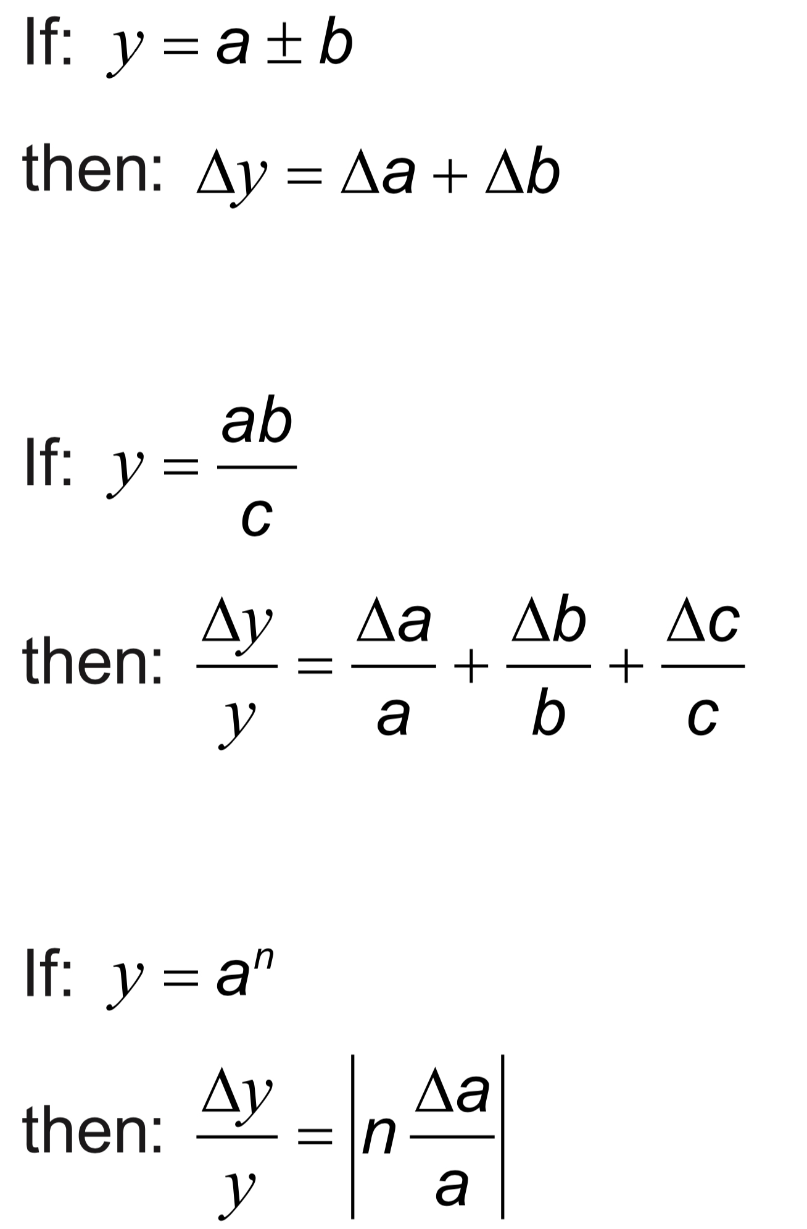 | Drawing/Diagram/Graph/Relationships
Essential idea: Some quantities have direction and magnitude, others have magnitude only, and this understanding is the key to correct manipulation of quantities. This sub- topic will have broad applications across multiple fields within physics and other sciences.

1.3 – Vectors and scalars

Nature of science:
Models: First mentioned explicitly in a scientific paper in 1846, scalars and vectors reflected the work of scientists and mathematicians across the globe for over 300 years on representing measurements in three-dimensional space. (1.10)

Understandings:  • Vector and scalar quantities  • Combination and resolution of vectors  Applications and skills:  • Solving vector problems graphically and algebraically  Guidance:  • Resolution of vectors will be limited to two perpendicular directions  • Problems will be limited to addition and subtraction of vectors and the multiplication and division of vectors by scalars  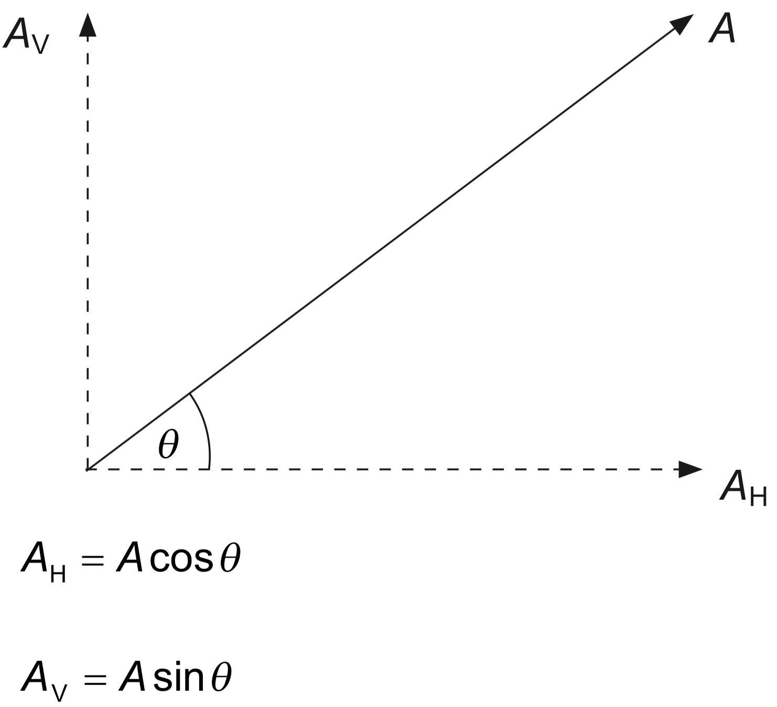  Data booklet reference: | Drawing/Diagram/Graph/Relationships

Topic 2: Mechanics (22 hours)
Syllabus Dissection

Essential idea: Motion may be described and analysed by the use of graphs and equations.

2.1 – Motion

Nature of science:
Observations: The ideas of motion are fundamental to many areas of physics, providing a link to the consideration of forces and their implication. The kinematic equations for uniform acceleration were developed through careful observations of the natural world. (1.8)

Topic 2: Mechanics
Understandings:  • Distance and displacement  • Speed and velocity  • Acceleration  • Graphs describing motion  • Equations of motion for uniform acceleration  • Projectile motion  • Fluid resistance and terminal speed  Applications and skills:  • Determining instantaneous and average values for velocity, speed and acceleration  • Solving problems using equations of motion for uniform acceleration  • Sketching and interpreting motion graphs  • Determining the acceleration of free-fall experimentally  • Analysing projectile motion, including the resolution of vertical and horizontal components of acceleration, velocity and displacement  • Qualitatively describing the effect of fluid resistance on falling objects or projectiles, including reaching terminal speed  Guidance:  • Calculations will be restricted to those neglecting air resistance  • Projectile motion will only involve problems using a constant value of g close to the surface of the Earth  • The equation of the path of a projectile will not be required  Data booklet reference:  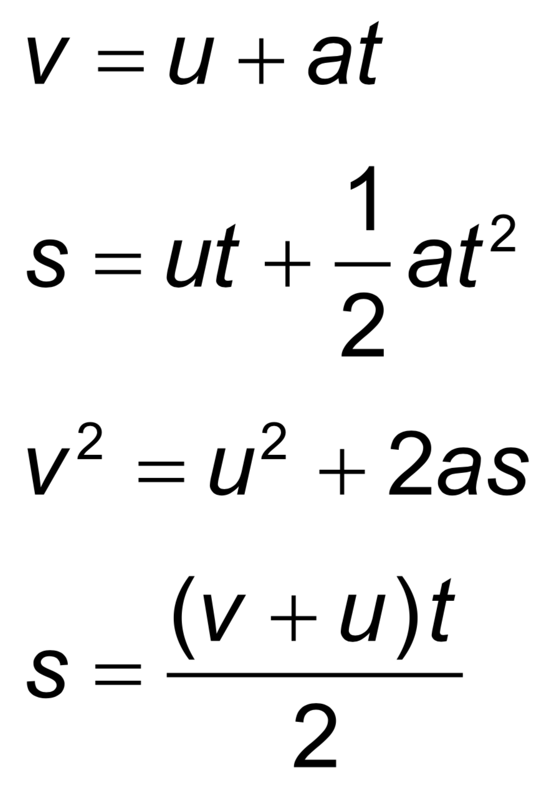 | Drawing/Diagram/Graph/Relationships
Essential idea: Classical physics requires a force to change a state of motion, as suggested by Newton in his laws of motion.
2.2 – Forces
Nature of science:
Using mathematics: Isaac Newton provided the basis for much of our understanding of forces and motion by formalizing the previous work of scientists through the application of mathematics by inventing calculus to assist with this. (2.4)
Intuition: The tale of the falling apple describes simply one of the many flashes of intuition that went into the publication of Philosophiæ Naturalis Principia Mathematica in 1687. (1.5)

Understandings:  - Objects as point particles  - Free-body diagrams  - Translational equilibrium  - Newton’s laws of motion  - Solid friction  Applications and skills:  • Representing forces as vectors  • Sketching and interpreting free-body diagrams  • Describing the consequences of Newton’s first law for translational equilibrium  • Using Newton’s second law quantitatively and qualitatively  • Identifying force pairs in the context of Newton’s third law  • Solving problems involving forces and determining resultant force  • Describing solid friction (static and dynamic) by coefficients of friction  Guidance:  • Students should label forces using commonly accepted names or symbols (for example: weight or force of gravity or mg)  • Free-body diagrams should show scaled vector lengths acting from the point of application  • Examples and questions will be limited to constant mass  • mg should be identified as weight  • Calculations relating to the determination of resultant forces will be restricted to one- and two-dimensional situations  Data booklet reference:  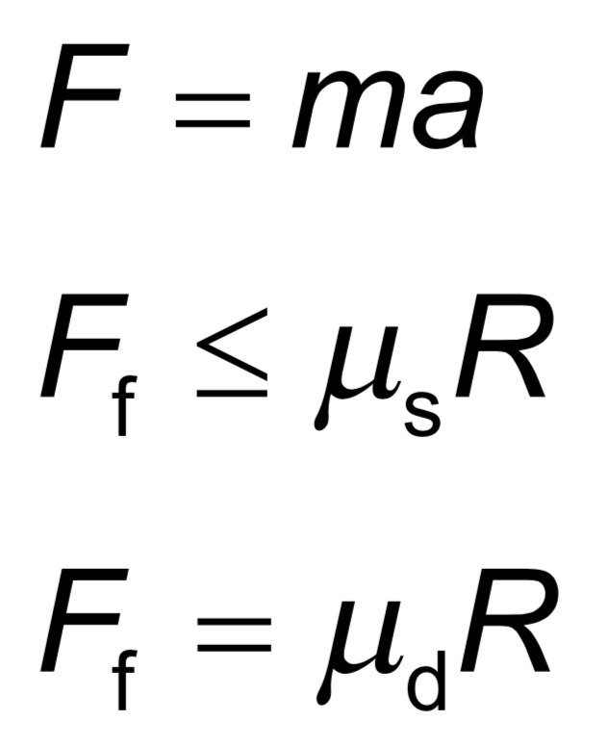 | Drawing/Diagram/Graph/Relationships

Essential idea: The fundamental concept of energy lays the basis upon which much of science is built.
2.3 – Work, energy and power
Nature of science:
Theories: Many phenomena can be fundamentally understood through application of the theory of conservation of energy. Over time, scientists have utilized this theory both to explain natural phenomena and, more importantly, to predict the outcome of previously unknown interactions. The concept of energy has evolved as a result of recognition of the relationship between mass and energy. (2.2)

Understandings:  • Kinetic energy  • Gravitational potential energy  • Elastic potential energy  • Work done as energy transfer  • Power as rate of energy transfer  • Principle of conservation of energy  • Efficiency  Applications and skills:  • Discussing the conservation of total energy within energy transformations  • Sketching and interpreting force–distance graphs  • Determining work done including cases where a resistive force acts  • Solving problems involving power  • Quantitatively describing efficiency in energy transfers  Guidance:  • Cases where the line of action of the force and the displacement are not parallel should be considered  • Examples should include force–distance graphs for variable forces  Data booklet reference:  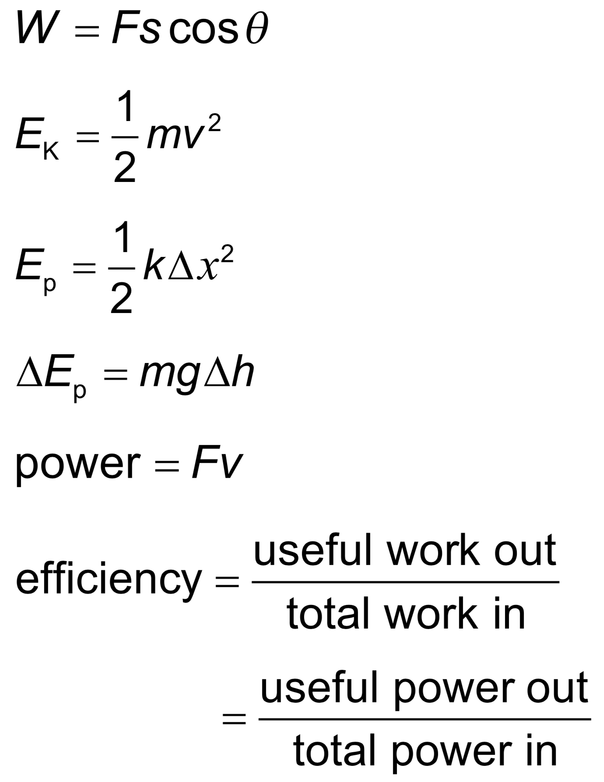 | Drawing/Diagram/Graph/Relationships

Essential idea: Conservation of momentum is an example of a law that is never violated.
2.4 – Momentum and impulse
Nature of science:
The concept of momentum and the principle of momentum conservation can be used to analyse and predict the outcome of a wide range of physical interactions, from macroscopic motion to microscopic collisions. (1.9)

Understandings:  • Newton’s second law expressed in terms of rate of change of momentum  • Impulse and force–time graphs  • Conservation of linear momentum  • Elastic collisions, inelastic collisions and explosions  Applications and skills:  • Applying conservation of momentum in simple isolated systems including (but not limited to) collisions, explosions, or water jets  • Using Newton’s second law quantitatively and qualitatively in cases where mass is not constant  • Sketching and interpreting force–time graphs  • Determining impulse in various contexts including (but not limited to) car safety and sports  • Qualitatively and quantitatively comparing situations involving elastic collisions, inelastic collisions and explosions  Guidance:  • Students should be aware that F = ma is equivalent of $F=\frac{∆p}{∆t}$ only when mass is constant  • Solving simultaneous equations involving conservation of momentum and energy in collisions will not be required  • Calculations relating to collisions and explosions will be restricted to onedimensional situations  • A comparison between energy involved in inelastic collisions (in which kinetic energy is not conserved) and the conservation of (total) energy should be made  Data booklet reference:  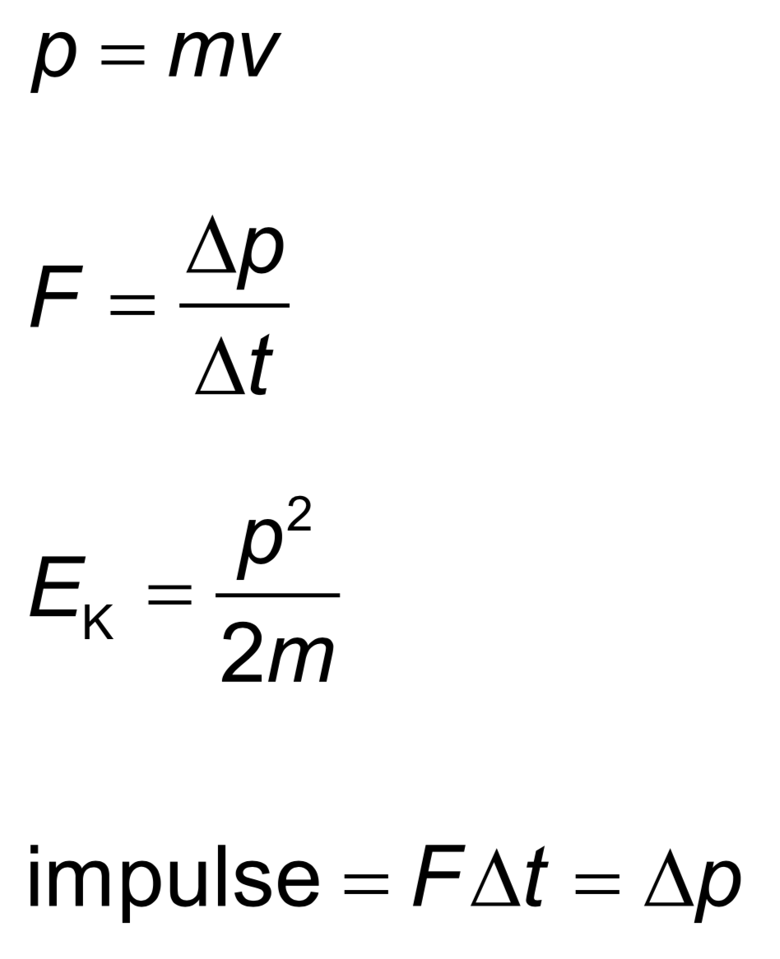 | Drawing/Diagram/Graph/Relationships

Topic 3: Thermal physics (11 hours)
Syllabus dissection
Essential idea: Thermal physics deftly demonstrates the links between the macroscopic measurements essential to many scientific models with the microscopic properties that underlie these models.
3.1 – Thermal concepts
Nature of science:
Evidence through experimentation: Scientists from the 17th and 18th centuries were working without the knowledge of atomic structure and sometimes developed theories that were later found to be incorrect, such as phlogiston and perpetual motion capabilities. Our current understanding relies on statistical mechanics providing a basis for our use and understanding of energy transfer in science. (1.8)

Topic 3: Thermal physcis
Understandings:  - Molecular theory of solids, liquids and gases  - Temperature and absolute temperature  - Internal energy  - Specific heat capacity  - Phase change  - Specific latent heat  Applications and skills:  • Describing temperature change in terms of internal energy  • Using Kelvin and Celsius temperature scales and converting between them  • Applying the calorimetric techniques of specific heat capacity or specific latent heat experimentally  • Describing phase change in terms of molecular behaviour  • Sketching and interpreting phase change graphs  • Calculating energy changes involving specific heat capacity and specific latent heat of fusion and vaporization  Guidance:  • Internal energy is taken to be the total intermolecular potential energy + the total random kinetic energy of the molecules  • Phase change graphs may have axes of temperature versus time or temperature versus energy  • The effects of cooling should be understood qualitatively but cooling correction calculations are not required  Data booklet reference:  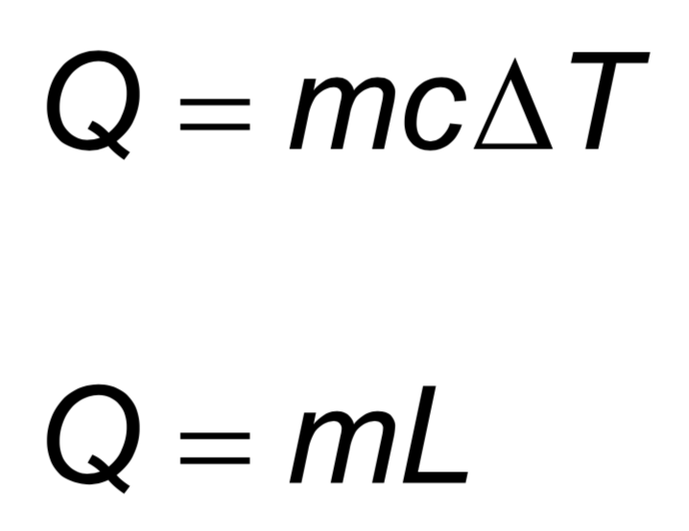 | Drawing/Diagram/Graph/Relationships

Essential idea: The properties of ideal gases allow scientists to make predictions of the behaviour of real gases.
3.2 – Modelling a gas
Nature of science:
Collaboration: Scientists in the 19th century made valuable progress on the modern theories that form the basis of thermodynamics, making important links with other sciences, especially chemistry. The scientific method was in evidence with contrasting but complementary statements of some laws derived by different scientists. Empirical and theoretical thinking both have their place in science and this is evident in the comparison between the unattainable ideal gas and real gases. (4.1)

Understandings:  - Pressure  - Equation of state for an ideal gas  - Kinetic model of an ideal gas  - Mole, molar mass and the Avogadro constant  - Differences between real and ideal gases  Applications and skills:  • Solving problems using the equation of state for an ideal gas and gas laws  • Sketching and interpreting changes of state of an ideal gas on pressure– volume, pressure–temperature and volume–temperature diagrams  • Investigating at least one gas law experimentally  Guidance:  • Students should be aware of the assumptions that underpin the molecular kinetic theory of ideal gases  • Gas laws are limited to constant volume, constant temperature, constant pressure and the ideal gas law  • Students should understand that a real gas approximates to an ideal gas at conditions of low pressure, moderate temperature and low density  Data booklet reference:  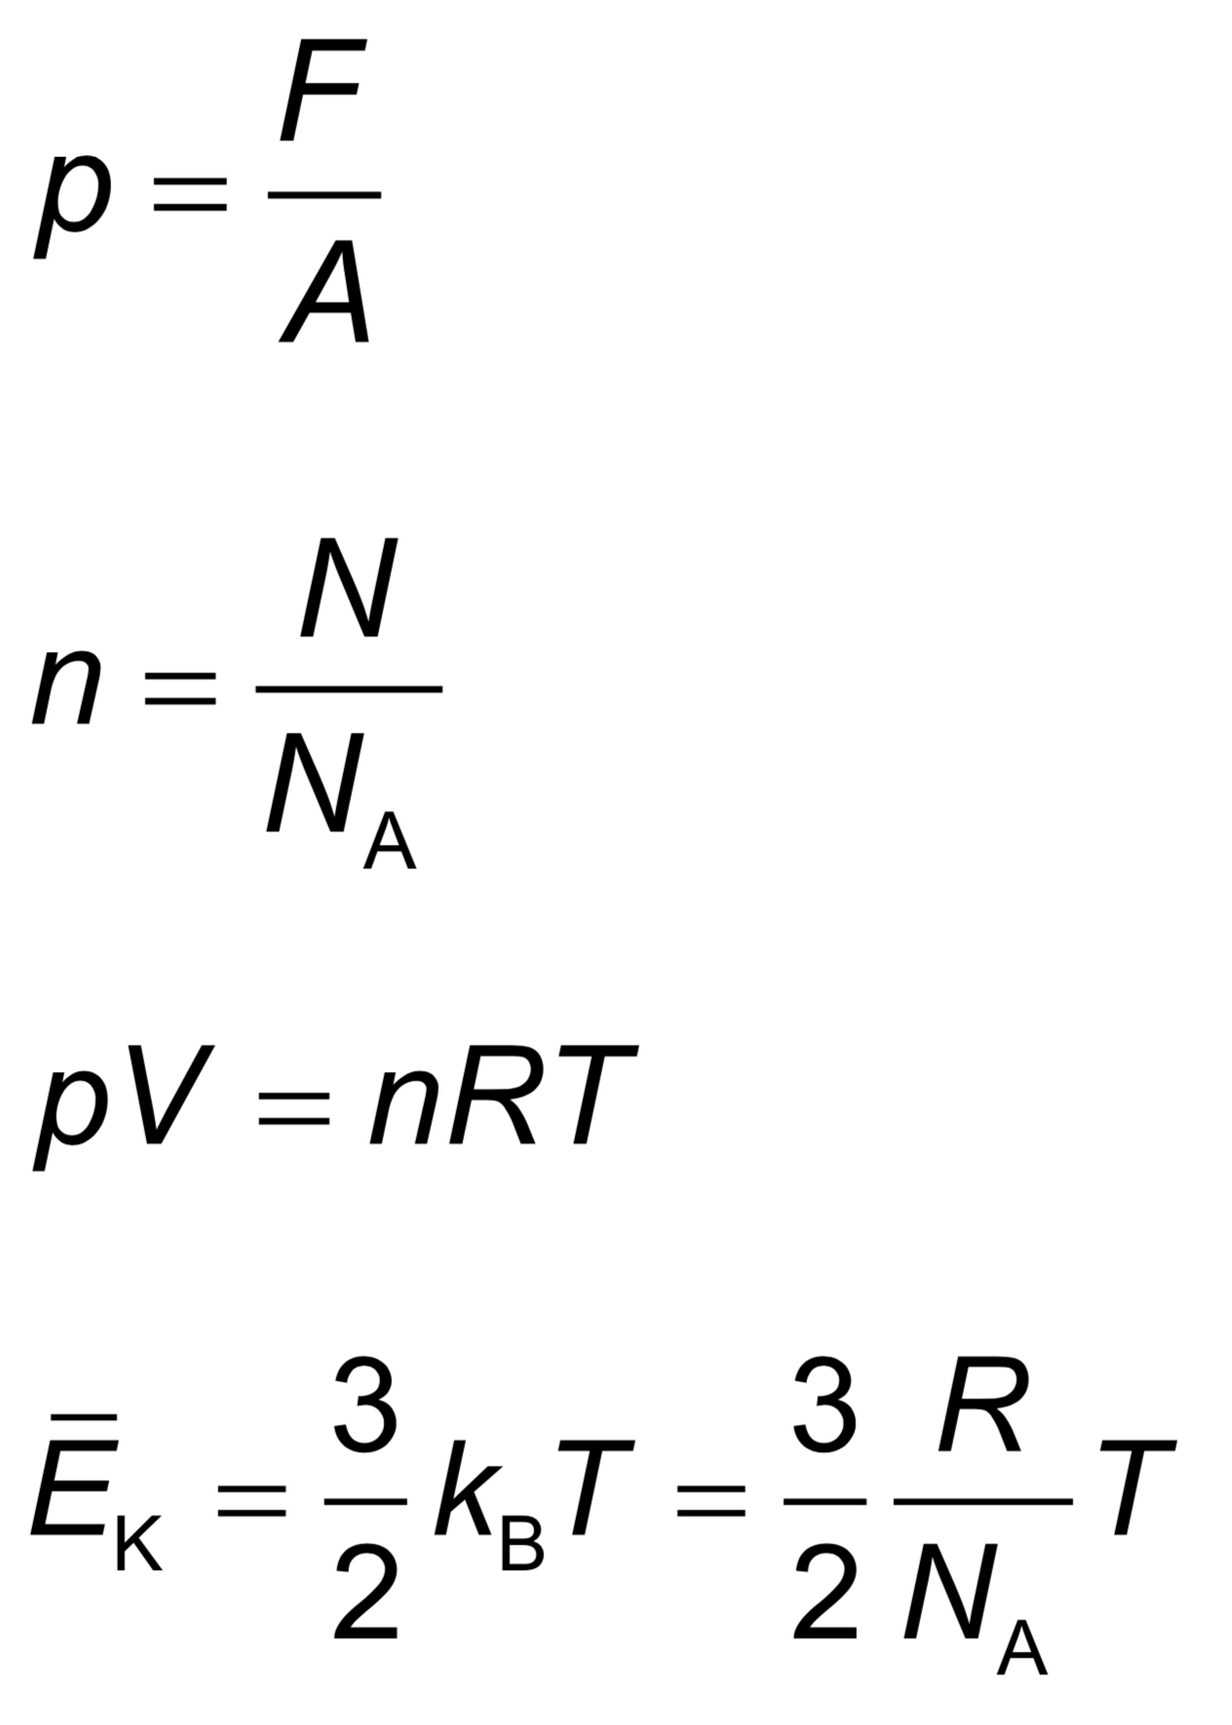 | Drawing/Diagram/Graph/Relationships

Topic 4: Waves (15 hours)
Syllabus dissection
Essential idea: A study of oscillations underpins many areas of physics with simple harmonic motion (shm), a fundamental oscillation that appears in various natural phenomena.
4.1 – Oscillations
Nature of science:
Models: Oscillations play a great part in our lives, from the tides to the motion of the swinging pendulum that once governed our perception of time. General principles govern this area of physics, from water waves in the deep ocean or the oscillations of a car suspension system. This introduction to the topic reminds us that not all oscillations are isochronous. However, the simple harmonic oscillator is of great importance to physicists because all periodic oscillations can be described through the mathematics of simple harmonic motion. (1.10)

Topic 4: Waves
Understandings:  - Simple harmonic oscillations  - Time period, frequency, amplitude, displacement and phase difference  - Conditions for simple harmonic motion  Applications and skills:  • Qualitatively describing the energy changes taking place during one cycle of an oscillation  • Sketching and interpreting graphs of simple harmonic motion examples  Guidance:  • Graphs describing simple harmonic motion should include displacement–time, velocity–time, acceleration–time and acceleration–displacement  • Students are expected to understand the significance of the negative sign in the relationship: a ∝ − x  Data booklet reference:  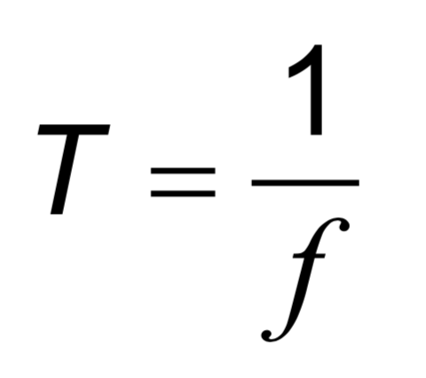 | Drawing/Diagram/Graph/Relationships

Essential idea: There are many forms of waves available to be studied. A common characteristic of all travelling waves is that they carry energy, but generally the medium through which they travel will not be permanently disturbed.
4.2 – Travelling Waves
Nature of science:
Patterns, trends and discrepancies: Scientists have discovered common features of wave motion through careful observations of the natural world, looking for patterns, trends and discrepancies and asking further questions based on these findings. (3.1)

Understandings:  - Travelling waves  - Wavelength, frequency, period and wave speed  - Transverse and longitudinal waves  - The nature of electromagnetic waves  - The nature of sound waves  Applications and skills:  • Explaining the motion of particles of a medium when a wave passes through it for both transverse and longitudinal cases  • Sketching and interpreting displacement–distance graphs and displacement–time graphs for transverse and longitudinal waves  • Solving problems involving wave speed, frequency and wavelength  • Investigating the speed of sound experimentally  Guidance:  • Students will be expected to derive c = fλ  • Students should be aware of the order of magnitude of the wavelengths of radio, microwave, infra-red, visible, ultraviolet, X-ray and gamma rays  Data booklet reference:  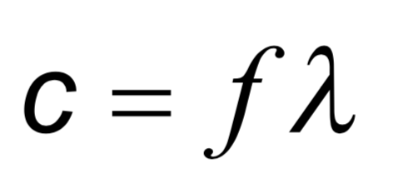 | Drawing/Diagram/Graph/Relationships

Essential idea: All waves can be described by the same sets of mathematical ideas. Detailed knowledge of one area leads to the possibility of prediction in another.
4.3 – Wave characteristics
Nature of science:
Imagination: It is speculated that polarization had been utilized by the Vikings through their use of Iceland Spar over 1300 years ago for navigation (prior to the introduction of the magnetic compass). Scientists across Europe in the 17th–19th centuries continued to contribute to wave theory by building on the theories and models proposed as our understanding developed. (1.4)

Understandings:  - Wavefronts and rays  - Amplitude and intensity  - Superposition  - Polarization  Applications and skills:  • Sketching and interpreting diagrams involving wavefronts and rays  • Solving problems involving amplitude, intensity and the inverse square law  • Sketching and interpreting the superposition of pulses and waves  • Describing methods of polarization  • Sketching and interpreting diagrams illustrating polarized, reflected and transmitted beams  • Solving problems involving Malus’s law  Guidance:  • Students will be expected to calculate the resultant of two waves or pulses both graphically and algebraically  • Methods of polarization will be restricted to the use of polarizing filters and reflection from a non-metallic plane surface  Data booklet reference:  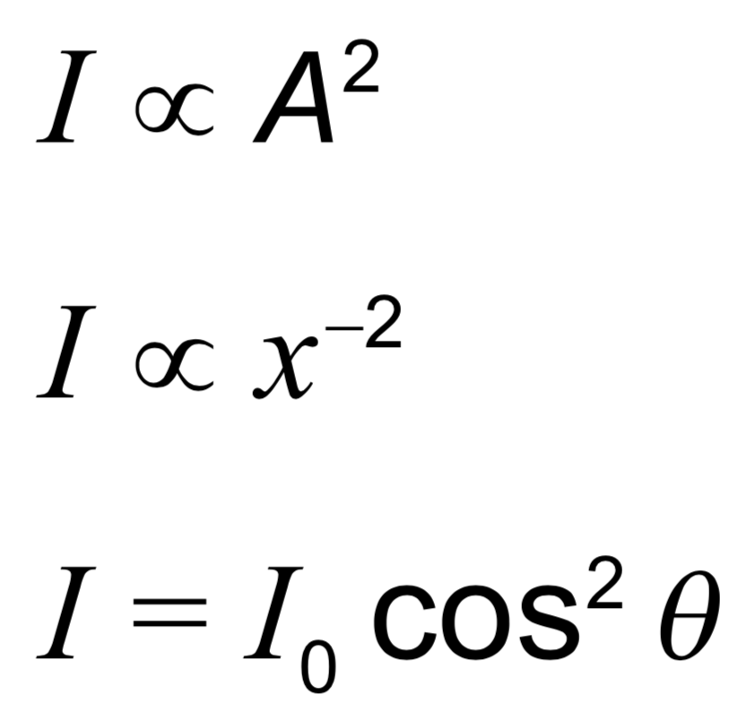 | Drawing/Diagram/Graph/Relationships
Essential idea: Waves interact with media and each other in a number of ways that can be unexpected and useful.
4.4 – Wave behaviour
Nature of science:
Competing theories: The conflicting work of Huygens and Newton on their theories of light and the related debate between Fresnel, Arago and Poisson are demonstrations of two theories that were valid yet flawed and incomplete. This is an historical example of the progress of science that led to the acceptance of the duality of the nature of light. (1.9)

Understandings:  - Reflection and refraction  - Snell’s law, critical angle and total internal reflection  - Diffraction through a single-slit and around objects  - Interference patterns  - Double-slit interference  - Path difference  Applications and skills:  • Sketching and interpreting incident, reflected and transmitted waves at boundaries between media  • Solving problems involving reflection at a plane interface  • Solving problems involving Snell’s law, critical angle and total internal reflection  • Determining refractive index experimentally  • Qualitatively describing the diffraction pattern formed when plane waves are incident normally on a single-slit  • Quantitatively describing double-slit interference intensity patterns  Guidance:  • Quantitative descriptions of refractive index are limited to light rays passing between two or more transparent media. If more than two media, only parallel interfaces will be considered  • Students will not be expected to derive the double-slit equation  • Students should have the opportunity to observe diffraction and interference patterns arising from more than one type of wave  Data booklet reference:  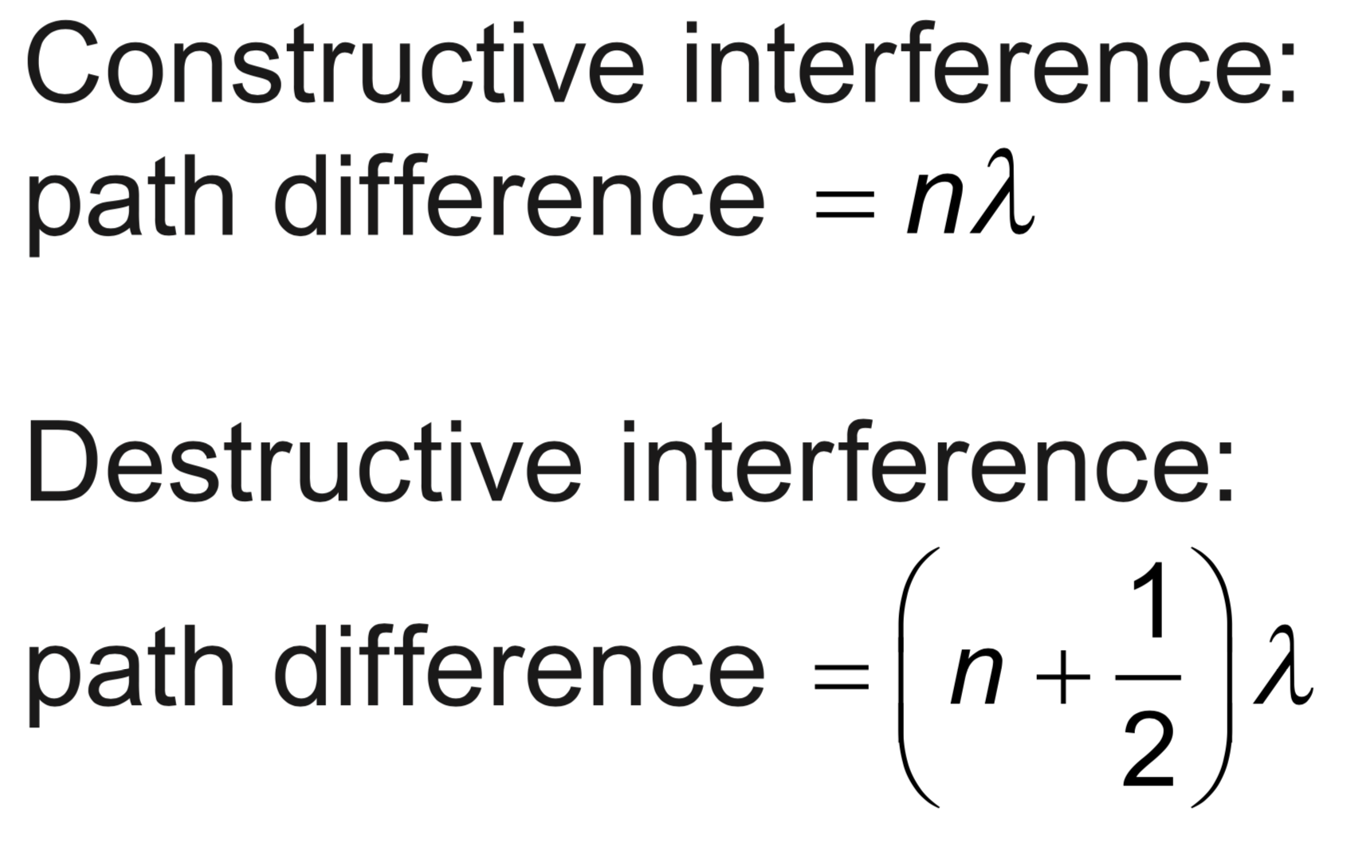  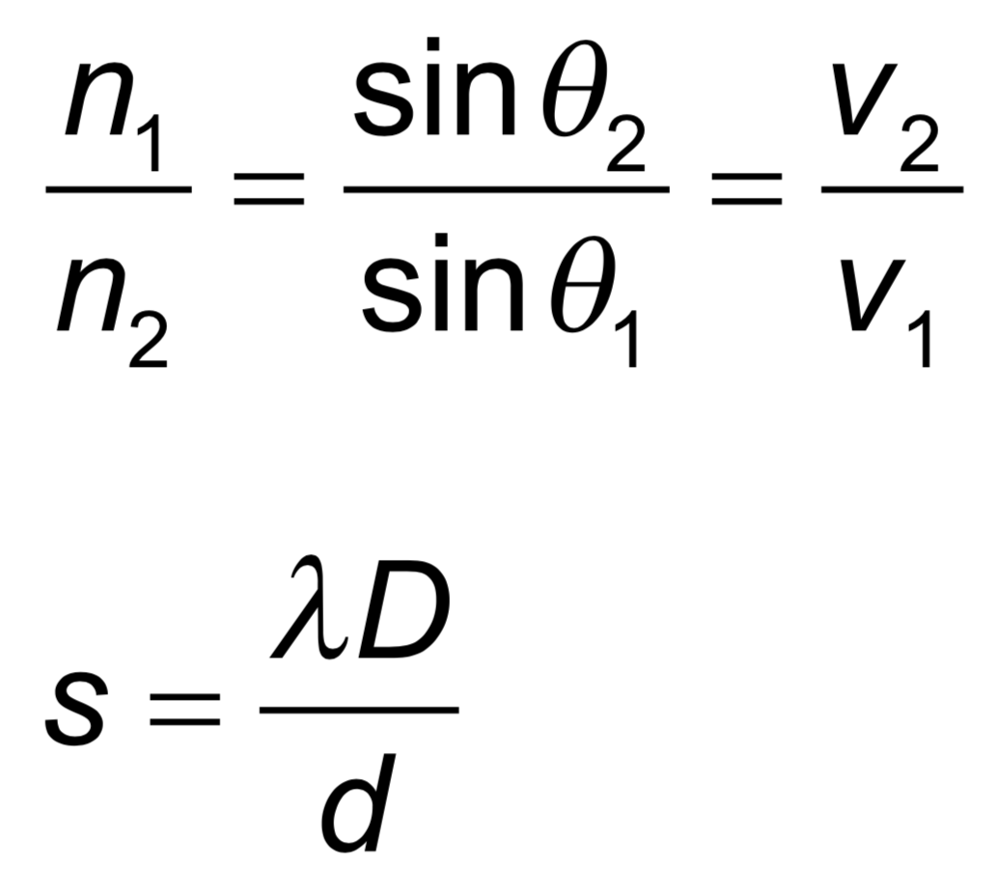 | Drawing/Diagram/Graph/Relationships
Essential idea: When travelling waves meet they can superpose to form standing waves in which energy may not be transferred.
4.5 – Standing waves
Nature of science:
Common reasoning process: From the time of Pythagoras onwards the connections between the formation of standing waves on strings and in pipes have been modelled mathematically and linked to the observations of the oscillating systems. In the case of sound in air and light, the system can be visualized in order to recognize the underlying processes occurring in the standing waves. (1.6)

Understandings:  • The nature of standing waves  • Boundary conditions  • Nodes and antinodes  Applications and skills:  • Describing the nature and formation of standing waves in terms of superposition  • Distinguishing between standing and travelling waves  • Observing, sketching and interpreting standing wave patterns in strings and pipes  • Solving problems involving the frequency of a harmonic, length of the standing wave and the speed of the wave  Guidance:  • Students will be expected to consider the formation of standing waves from the superposition of no more than two waves  • Boundary conditions for strings are: two fixed boundaries; fixed and free boundary; two free boundaries  • Boundary conditions for pipes are: two closed boundaries; closed and open boundary; two open boundaries  • For standing waves in air, explanations will not be required in terms of pressure nodes and pressure antinodes  • The lowest frequency mode of a standing wave is known as the first harmonic  • The terms fundamental and overtone will not be used in examination questions  Data booklet reference:  none | Drawing/Diagram/Graph/Relationships

Topic 5: Electricity and magnetism (15 hours)
Syllabus dissection
Essential idea: When charges move an electric current is created.
5.1 – Electric fields
Nature of science:
Modelling: Electrical theory demonstrates the scientific thought involved in the development of a microscopic model (behaviour of charge carriers) from macroscopic observation. The historical development and refinement of these scientific ideas when the microscopic properties were unknown and unobservable is testament to the deep thinking shown by the scientists of the time. (1.10)

Topic 5:Electricity and magnetism
Understandings:  • Charge  • Electric field  • Coulomb’s law  • Electric current  • Direct current (dc)  • Potential difference  Applications and skills:  • Identifying two forms of charge and the direction of the forces between them  • Solving problems involving electric fields and Coulomb’s law  • Calculating work done in an electric field in both joules and electronvolts  • Identifying sign and nature of charge carriers in a metal  • Identifying drift speed of charge carriers  • Solving problems using the drift speed equation  • Solving problems involving current, potential difference and charge  Guidance:  • Students will be expected to apply Coulomb’s law for a range of permittivity values  Data booklet reference:  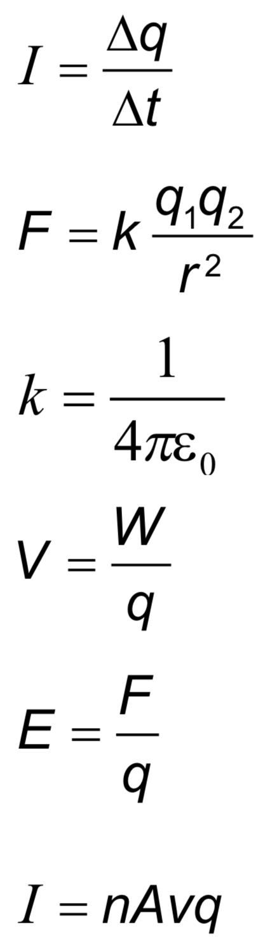 | Drawing/Diagram/Graph/Relationships

Essential idea: One of the earliest uses for electricity was to produce light and heat. This technology continues to have a major impact on the lives of people around the world.
5.2 – Heating effect of electric currents
Nature of science:
Peer review: Although Ohm and Barlow published their findings on the nature of electric current around the same time, little credence was given to Ohm. Barlow’s incorrect law was not initially criticized or investigated further. This is a reflection of the nature of academia of the time, with physics in Germany being largely non-mathematical and Barlow held in high respect in England. It indicates the need for the publication and peer review of research findings in recognized scientific journals. (4.4)

Understandings:  • Circuit diagrams  • Kirchhoff’s circuit laws  • Heating effect of current and its consequences  • Resistance expressed as $R=\frac{V}{I}$  • Ohm’s law  • Resistivity  • Power dissipation  Applications and skills:  • Drawing and interpreting circuit diagrams  • Identifying ohmic and non-ohmic conductors through a consideration of the V/I characteristic graph  • Solving problems involving potential difference, current, charge, Kirchhoff’s circuit laws, power, resistance and resistivity  • Investigating combinations of resistors in parallel and series circuits  • Describing ideal and non-ideal ammeters and voltmeters  • Describing practical uses of potential divider circuits, including the advantages of a potential divider over a series resistor in controlling a simple circuit  • Investigating one or more of the factors that affect resistance experimentally  Guidance:  • The filament lamp should be described as a non-ohmic device; a metal wire at a constant temperature is an ohmic device  • The use of non-ideal voltmeters is confined to voltmeters with a constant but finite resistance  • The use of non-ideal ammeters is confined to ammeters with a constant but non-zero resistance  • Application of Kirchhoff’s circuit laws will be limited to circuits with a maximum number of two source-carrying loops  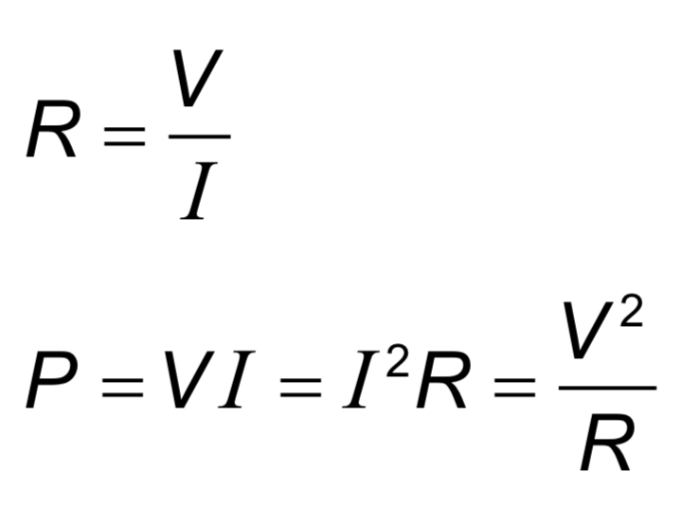  Data booklet reference:  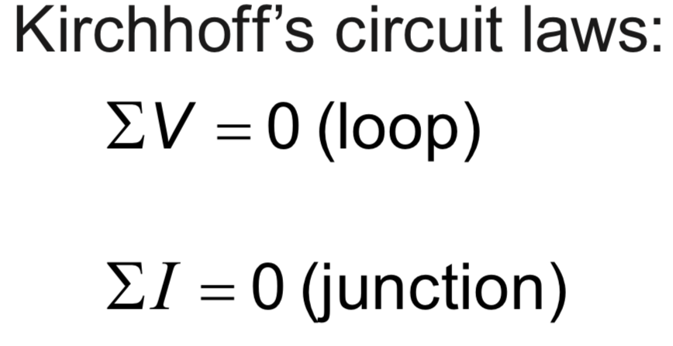 | 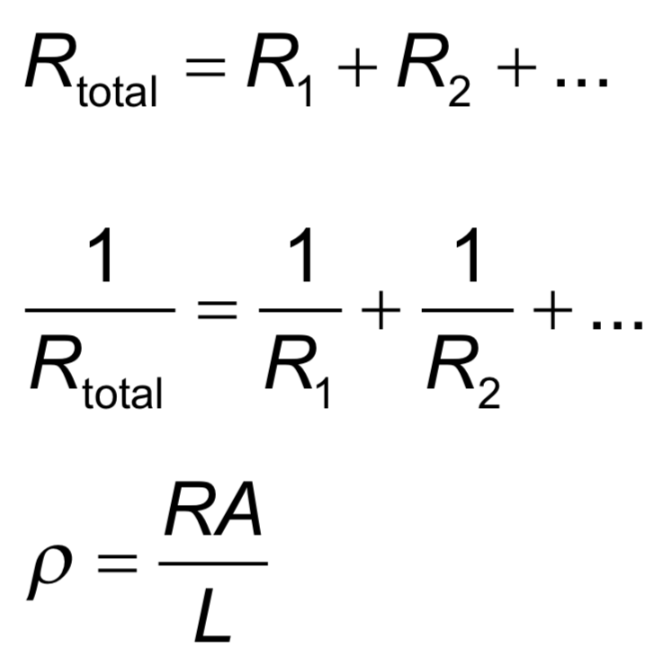  Drawing/Diagram/Graph/Relationships
Essential idea: Electric cells allow us to store energy in a chemical form.
5.3 – Electric cells
Nature of science:
Long-term risks: Scientists need to balance the research into electric cells that can store energy with greater energy density to provide longer device lifetimes with the long-term risks associated with the disposal of the chemicals involved when batteries are discarded. (4.8)

Understandings:  • Cells  • Internal resistance  • Secondary cells  • Terminal potential difference  • Emf  Applications and skills:  • Investigating practical electric cells (both primary and secondary)  • Describing the discharge characteristic of a simple cell (variation of terminal potential difference with time)  • Identifying the direction of current flow required to recharge a cell  • Determining internal resistance experimentally  • Solving problems involving emf, internal resistance and other electrical quantities  Guidance:  • Students should recognize that the terminal potential difference of a typical practical electric cell loses its initial value quickly, has a stable and constant value for most of its lifetime, followed by a rapid decrease to zero as the cell discharges completely  Data booklet reference:  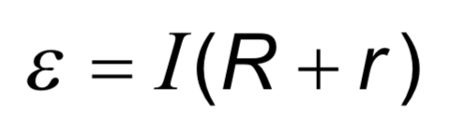 | Drawing/Diagram/Graph/Relationships

Essential idea: The effect scientists call magnetism arises when one charge moves in the vicinity of another moving charge.
5.4 – Magnetic effects of electric currents
Nature of science:
Models and visualization: Magnetic field lines provide a powerful visualization of a magnetic field. Historically, the field lines helped scientists and engineers to understand a link that begins with the influence of one moving charge on another and leads onto relativity. (1.10)

Understandings:  • Magnetic fields  • Magnetic force  Applications and skills:  • Determining the direction of force on a charge moving in a magnetic field  • Determining the direction of force on a current-carrying conductor in a magnetic field  • Sketching and interpreting magnetic field patterns  • Determining the direction of the magnetic field based on current direction  • Solving problems involving magnetic forces, fields, current and charges  Guidance:  • Magnetic field patterns will be restricted to long straight conductors, solenoids, and bar magnets  Data booklet reference:  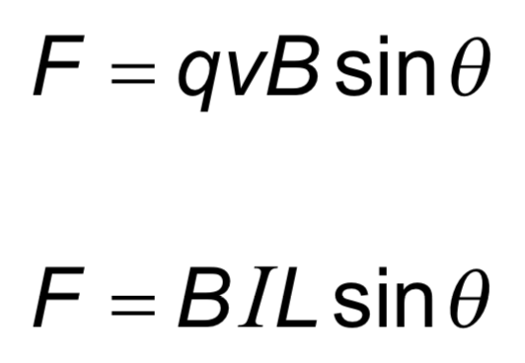 | Drawing/Diagram/Graph/Relationships

Topic 6: Circular motion and gravitation (5 hours)
Syllabus dissection
Essential idea: A force applied perpendicular to its displacement can result in circular motion.
6.1 – Circular motion
Nature of science:
Observable universe: Observations and subsequent deductions led to the realization that the force must act radially inwards in all cases of circular motion. (1.1)

Topic 6: Circular motion and gravitation
Understandings:  • Period, frequency, angular displacement and angular velocity  • Centripetal force  • Centripetal acceleration  Applications and skills:  • Identifying the forces providing the centripetal forces such as tension, friction, gravitational, electrical, or magnetic  • Solving problems involving centripetal force, centripetal acceleration, period, frequency, angular displacement, linear speed and angular velocity  • Qualitatively and quantitatively describing examples of circular motion including cases of vertical and horizontal circular motion  Guidance:  • Banking will be considered qualitatively only  Data booklet reference:  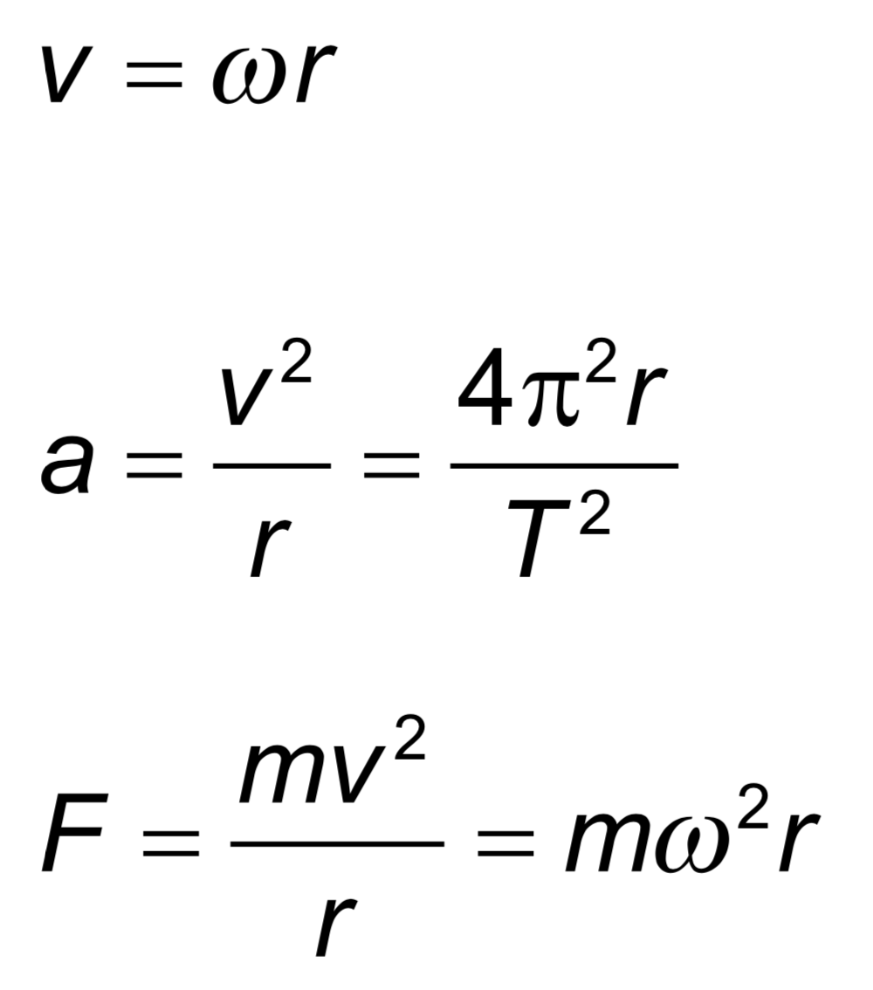 | Drawing/Diagram/Graph/Relationships
Essential idea: The Newtonian idea of gravitational force acting between two spherical bodies and the laws of mechanics create a model that can be used to calculate the motion of planets.
6.2 – Newton’s law of gravitation
Nature of science:
Laws: Newton’s law of gravitation and the laws of mechanics are the foundation for deterministic classical physics. These can be used to make predictions but do not explain why the observed phenomena exist. (2.4)

Understandings:  • Newton’s law of gravitation  • Gravitational field strength  Applications and skills:  • Describing the relationship between gravitational force and centripetal force  • Applying Newton’s law of gravitation to the motion of an object in circular orbit around a point mass  • Solving problems involving gravitational force, gravitational field strength, orbital speed and orbital period  • Determining the resultant gravitational field strength due to two bodies  Guidance:  • Newton’s law of gravitation should be extended to spherical masses of uniform density by assuming that their mass is concentrated at their centre  • Gravitational field strength at a point is the force per unit mass experienced by a small point mass at that point  • Calculations of the resultant gravitational field strength due to two bodies will be restricted to points along the straight line joining the bodies  Data booklet reference:  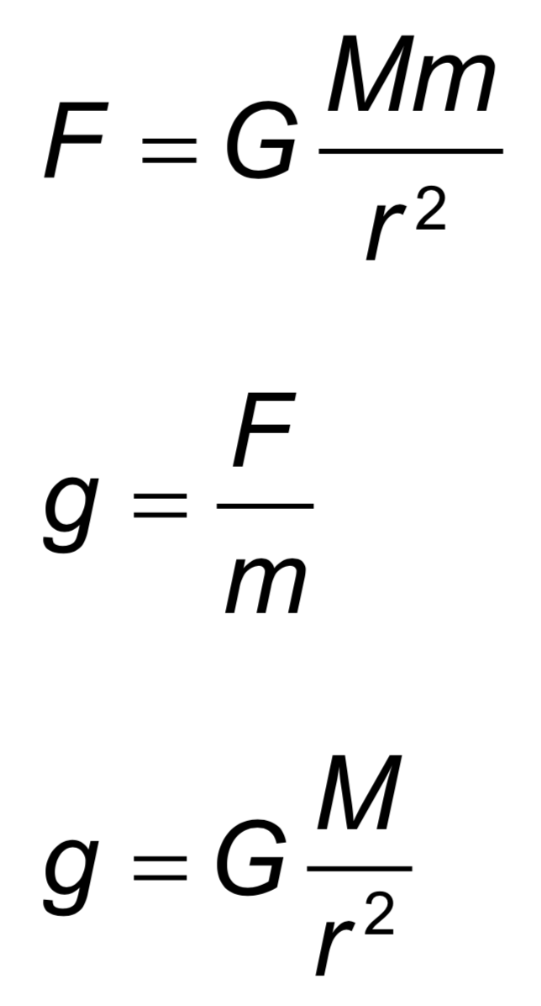 | Drawing/Diagram/Graph/Relationships

Topic 7: Atomar, nuclear and particle physics (14 hours)
Syllabus dissection

Essential idea: In the microscopic world energy is discrete.
7.1 – Discrete energy and radioactivity
Nature of science:
Accidental discovery: Radioactivity was discovered by accident when Becquerel developed photographic film that had accidentally been exposed to radiation from radioactive rocks. The marks on the photographic film seen by Becquerel probably would not lead to anything further for most people. What Becquerel did was to correlate the presence of the marks with the presence of the radioactive rocks and investigate the situation further. (1.4)

Topic 7: Atomar, nuclear and partice physics
Understandings:  • Discrete energy and discrete energy levels  • Transitions between energy levels  • Radioactive decay  • Fundamental forces and their properties  • Alpha particles, beta particles and gamma rays  • Half-life  • Absorption characteristics of decay particles  • Isotopes  • Background radiation  Applications and skills:  • Describing the emission and absorption spectrum of common gases  • Solving problems involving atomic spectra, including calculating the wavelength of photons emitted during atomic transitions  • Completing decay equations for alpha and beta decay  • Determining the half-life of a nuclide from a decay curve  • Investigating half-life experimentally (or by simulation)  Guidance:  • Students will be required to solve problems on radioactive decay involving only integral numbers of half-lives  • Students will be expected to include the neutrino and antineutrino in beta decay equations  Data booklet reference:  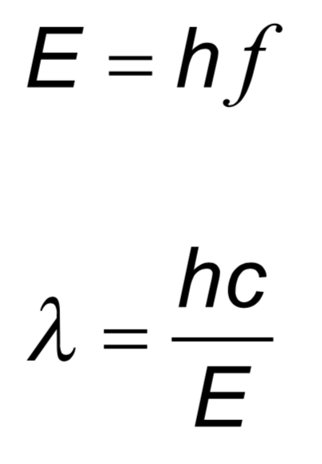 | Drawing/Diagram/Graph/Relationships
Essential idea: Energy can be released in nuclear decays and reactions as a result of the relationship between mass and energy.
7.2 – Nuclear reactions
Nature of science:
Patterns, trends and discrepancies: Graphs of binding energy per nucleon and of neutron number versus proton number reveal unmistakable patterns. This allows scientists to make predictions of isotope characteristics based on these graphs. (3.1)

Understandings:  • The unified atomic mass unit  • Mass defect and nuclear binding energy  • Nuclear fission and nuclear fusion  Applications and skills:  • Solving problems involving mass defect and binding energy  • Solving problems involving the energy released in radioactive decay, nuclear fission and nuclear fusion  • Sketching and interpreting the general shape of the curve of average binding energy per nucleon against nucleon number  Guidance:  • Students must be able to calculate changes in terms of mass or binding energy  • Binding energy may be defined in terms of energy required to completely separate the nucleons or the energy released when a nucleus is formed from its nucleons  Data booklet reference:  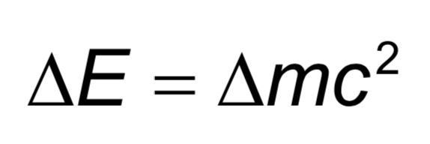 | Drawing/Diagram/Graph/Relationships
Essential idea: It is believed that all the matter around us is made up of fundamental particles called quarks and leptons. It is known that matter has a hierarchical structure with quarks making up nucleons, nucleons making up nuclei, nuclei and electrons making up atoms and atoms making up molecules. In this hierarchical structure, the smallest scale is seen for quarks and leptons (10^{–18}m).
7.3 – The structure of matter
Nature of science:
Predictions: Our present understanding of matter is called the Standard Model, consisting of six quarks and six leptons. Quarks were postulated on a completely mathematical basis in order to explain patterns in properties of particles. (1.9)

Collaboration: It was much later that large-scale collaborative experimentation led to the discovery of the predicted fundamental particles. (4.3)

Understandings:  • Quarks, leptons and their antiparticles  • Hadrons, baryons and mesons  • The conservation laws of charge, baryon number, lepton number and strangeness  • The nature and range of the strong nuclear force, weak nuclear force and electromagnetic force  • Exchange particles  • Feynman diagrams  • Confinement  • The Higgs boson  Applications and skills:  • Describing the Rutherford-Geiger-Marsden experiment that led to the discovery of the nucleus  • Applying conservation laws in particle reactions  • Describing protons and neutrons in terms of quarks  • Comparing the interaction strengths of the fundamental forces, including gravity  • Describing the mediation of the fundamental forces through exchange particles  • Sketching and interpreting simple Feynman diagrams  • Describing why free quarks are not observed  Guidance:  • A qualitative description of the standard model is required  Data booklet reference:  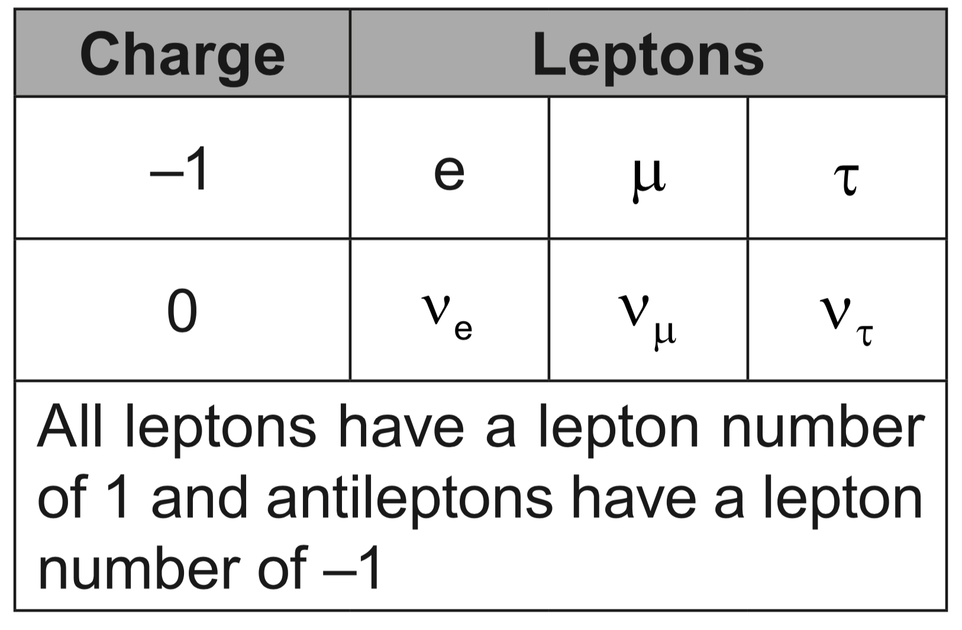 | 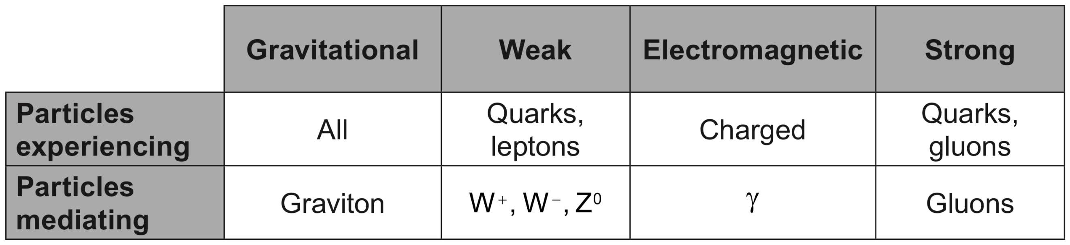  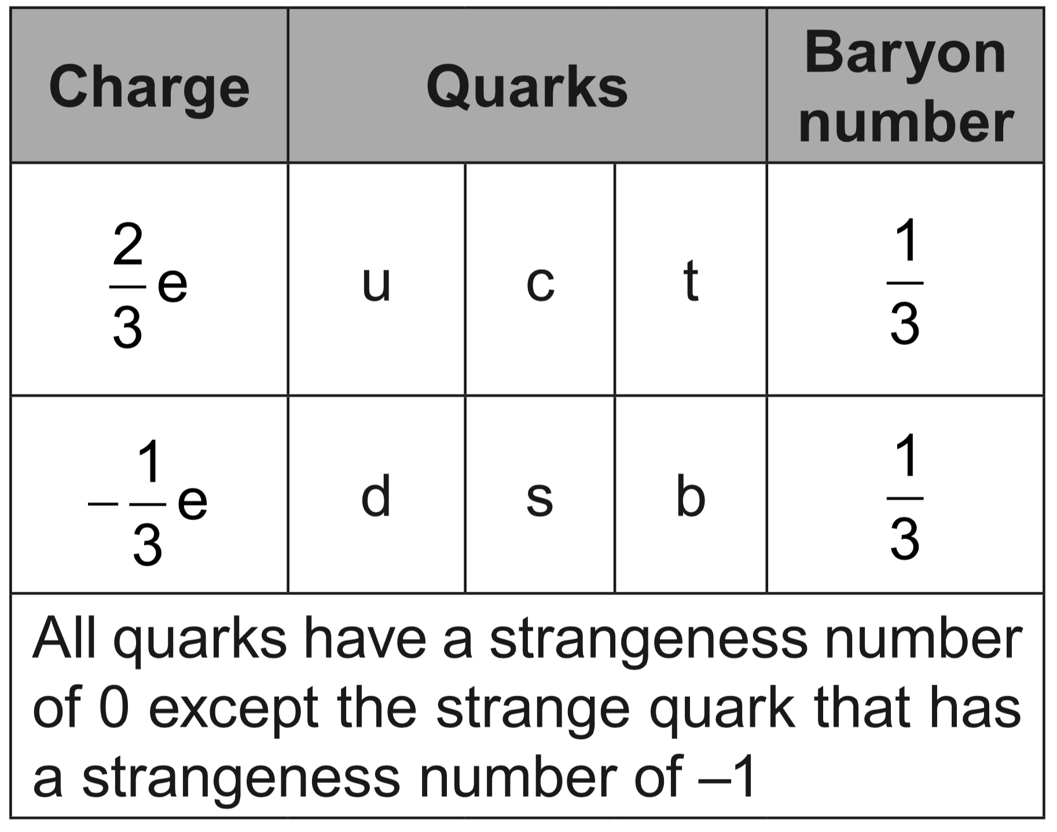  Drawing/Diagram/Graph/Relationships
Topic 8: Energy production (8 hours)
Syllabus dissection

Essential idea: The constant need for new energy sources implies decisions that may have a serious effect on the environment. The finite quantity of fossil fuels and their implication in global warming has led to the development of alternative sources of energy. This continues to be an area of rapidly changing technological innovation.
8.1 – Energy sources
Nature of science:
Risks and problem-solving: Since early times mankind understood the vital role of harnessing energy and large-scale production of electricity has impacted all levels of society. Processes where energy is transformed require holistic approaches that involve many areas of knowledge. Research and development of alternative energy sources has lacked support in some countries for economic and political reasons. Scientists, however, have continued to collaborate and share new technologies that can reduce our dependence on non-renewable energy sources. (4.8)

Topic 8: Energy production
Understandings:  • Specific energy and energy density of fuel sources  • Sankey diagrams  • Primary energy sources  • Electricity as a secondary and versatile form of energy  • Renewable and non-renewable energy sources  Applications and skills:  • Solving specific energy and energy density problems  • Sketching and interpreting Sankey diagrams  • Describing the basic features of fossil fuel power stations, nuclear power stations, wind generators, pumped storage hydroelectric systems and solar power cells  • Solving problems relevant to energy transformations in the context of these generating systems  • Discussing safety issues and risks associated with the production of nuclear power  • Describing the differences between photovoltaic cells and solar heating panels  Guidance:  • Specific energy has units of J kg^{–1}; energy density has units of J m^{–3}  • The description of the basic features of nuclear power stations must include the use of control rods, moderators and heat exchangers  • Derivation of the wind generator equation is not required but an awareness of relevant assumptions and limitations is required  • Students are expected to be aware of new and developing technologies which may become important during the life of this guide  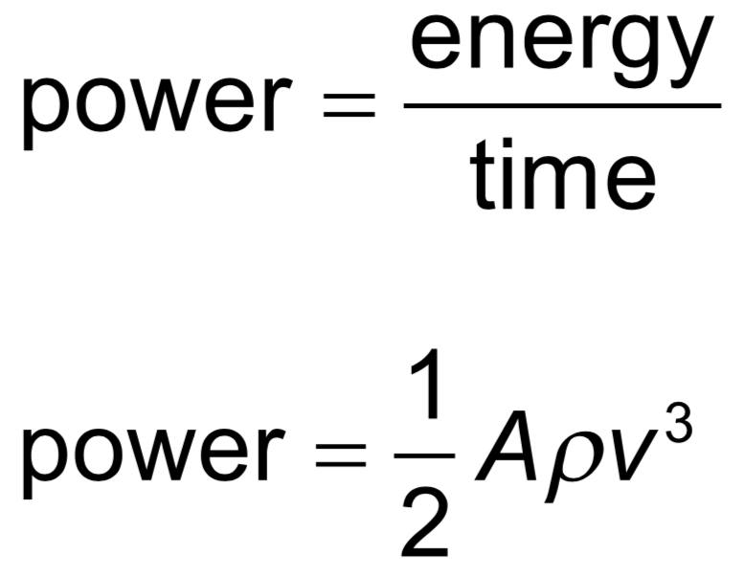  Data booklet reference: | Drawing/Diagram/Graph/Relationships
Essential idea: For simplified modelling purposes the Earth can be treated as a black-body radiator and the atmosphere treated as a grey-body.
8.2 – Thermal energy transfer
Nature of science:
Simple and complex modelling: The kinetic theory of gases is a simple mathematical model that produces a good approximation of the behaviour of real gases. Scientists are also attempting to model the Earth’s climate, which is a far more complex system. Advances in data availability and the ability to include more processes in the models together with continued testing and scientific debate on the various models will improve the ability to predict climate change more accurately. (1.12)

Understandings:  • Conduction, convection and thermal radiation  • Black-body radiation  • Albedo and emissivity  • The solar constant  • The greenhouse effect  • Energy balance in the Earth surface–atmosphere system  Applications and skills:  • Sketching and interpreting graphs showing the variation of intensity with wavelength for bodies emitting thermal radiation at different temperatures  • Solving problems involving the Stefan–Boltzmann law and Wien’s displacement law  • Describing the effects of the Earth’s atmosphere on the mean surface temperature  • Solving problems involving albedo, emissivity, solar constant and the Earth’s average temperature  Guidance:  • Discussion of conduction and convection will be qualitative only  • Discussion of conduction is limited to intermolecular and electron collisions  • Discussion of convection is limited to simple gas or liquid transfer via density differences  • The absorption of infrared radiation by greenhouse gases should be described in terms of the molecular energy levels and the subsequent emission of radiation in all directions  • The greenhouse gases to be considered are CH₄, H₂O, CO₂ and N₂O. It is sufficient for students to know that each has both natural and man-made origins.  • Earth’s albedo varies daily and is dependent on season (cloud formations) and latitude. The global annual mean albedo will be taken to be 0.3 (30%) for Earth.  Data booklet reference: | 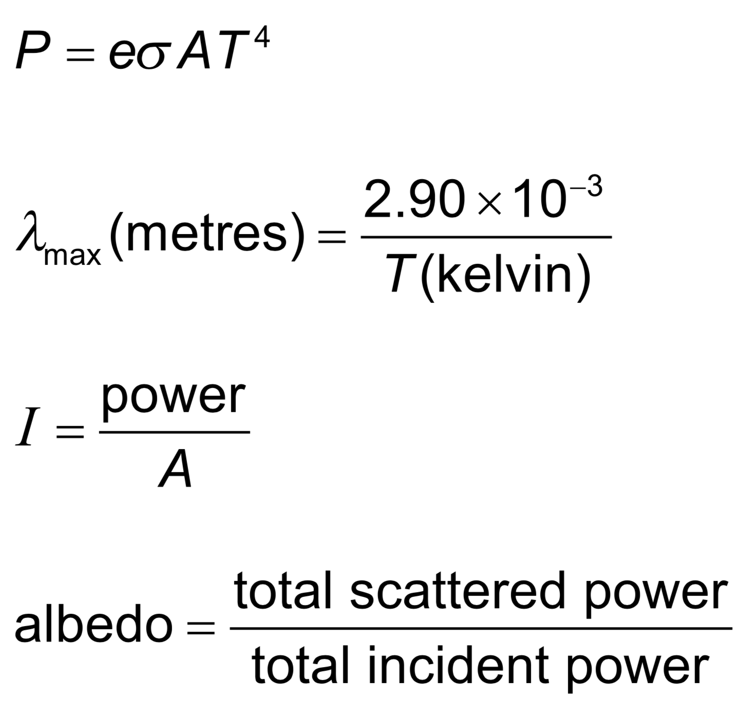  Drawing/Diagram/Graph/Relationships

Topic 9: Wave phenomena (17 hours)
Syllabus dissection

Essential idea: The solution of the harmonic oscillator can be framed around the variation of kinetic and potential energy in the system.
9.1 – Simple harmonic motion
Nature of science:
Insights: The equation for simple harmonic motion (SHM) can be solved analytically and numerically. Physicists use such solutions to help them to visualize the behavior of the oscillator. The use of the equations is very powerful as any oscillation can be described in terms of a combination of harmonic oscillators. Numerical modelling of oscillators is important in the design of electrical circuits. (1.11)

Topic 9: Wave phenomena
Understandings:  • The defining equation of SHM  • Energy changes  Applications and skills:  • Solving problems involving acceleration, velocity and displacement during simple harmonic motion, both graphically and algebraically  • Describing the interchange of kinetic and potential energy during simple harmonic motion  • Solving problems involving energy transfer during simple harmonic motion, both graphically and algebraically  Guidance:  • Contexts for this sub-topic include the simple pendulum and a mass-spring system  Data booklet reference:  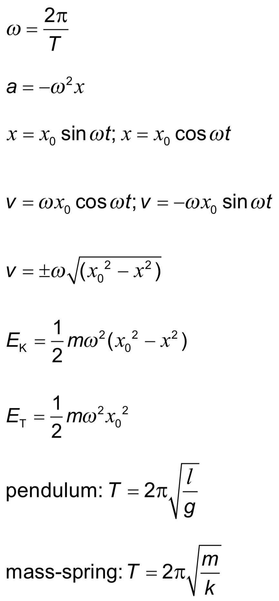 | Drawing/Diagram/Graph/Relationships

Essential idea: Single-slit diffraction occurs when a wave is incident upon a slit of approximately the same size as the wavelength.
9.2 – Single-slit-diffraction
Nature of science:
Development of theories: When light passes through an aperture the summation of all parts of the wave leads to an intensity pattern that is far removed from the geometrical shadow that simple theory predicts. (1.9)

Understandings:  • The nature of single-slit diffraction  Applications and skills:  • Describing the effect of slit width on the diffraction pattern  • Determining the position of first interference minimum  • Qualitatively describing single-slit diffraction patterns produced from white light and from a range of monochromatic light frequencies  Guidance:  • Only rectangular slits need to be considered  • Diffraction around an object (rather than through a slit) does not need to be considered in this sub-topic (see Physics sub-topic 4.4)  • Students will be expected to be aware of the approximate ratios of successive intensity maxima for single-slit interference patterns  • Calculations will be limited to a determination of the position of the first minimum for single-slit interference patterns using the approximation equation  Data booklet reference:  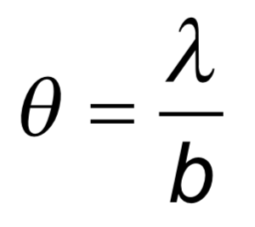 | Drawing/Diagram/Graph/Relationships

Essential idea: Interference patterns from multiple slits and thin films produce accurately repeatable patterns.
9.3 – Interference
Nature of science:
Curiosity: Observed patterns of iridescence in animals, such as the shimmer of peacock feathers, led scientists to develop the theory of thin film interference. (1.5)
Serendipity: The first laboratory production of thin films was accidental. (1.5)

Understandings:  • Young’s double-slit experiment  • Modulation of two-slit interference pattern by one-slit diffraction effect  • Multiple slit and diffraction grating interference patterns  • Thin film interference  Applications and skills:  • Qualitatively describing two-slit interference patterns, including modulation by one-slit diffraction effect  • Investigating Young’s double-slit experimentally  • Sketching and interpreting intensity graphs of double-slit interference patterns  • Solving problems involving the diffraction grating equation  • Describing conditions necessary for constructive and destructive interference from thin films, including phase change at interface and effect of refractive index  • Solving problems involving interference from thin films  Guidance:  • Students should be introduced to interference patterns from a variety of coherent sources such as (but not limited to) electromagnetic waves, sound and simulated demonstrations  • Diffraction grating patterns are restricted to those formed at normal incidence  • The treatment of thin film interference is confined to parallel-sided films at normal incidence  • The constructive interference and destructive interference formulae listed below and in the data booklet apply to specific cases of phase changes at interfaces and are not generally true  Data booklet reference:  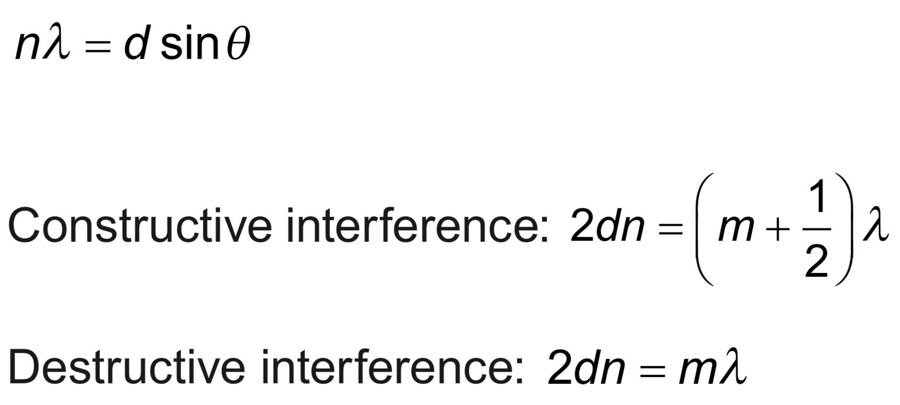 | Drawing/Diagram/Graph/Relationships
Essential idea: Resolution places an absolute limit on the extent to which an optical or other system can separate images of objects.
9.4 – Resolution
Nature of science:
Improved technology: The Rayleigh criterion is the limit of resolution. Continuing advancement in technology such as large diameter dishes or lenses or the use of smaller wavelength lasers pushes the limits of what we can resolve. (1.8)

Understandings:  • The size of a diffracting aperture  • The resolution of simple monochromatic two-source systems  Applications and skills:  • Solving problems involving the Rayleigh criterion for light emitted by two sources diffracted at a single slit  • Resolvance of diffraction gratings  Guidance:  • Proof of the diffraction grating resolvance equation is not required  Data booklet reference:  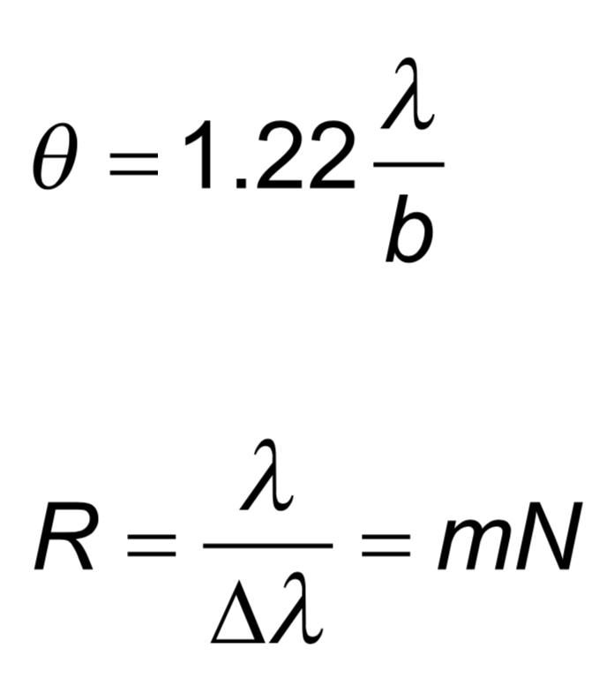 | Drawing/Diagram/Graph/Relationships

Essential idea: The Doppler effect describes the phenomenon of wavelength/frequency shift when relative motion occurs.
9.5 – Doppler effect
Nature of science:
Technology: Although originally based on physical observations of the pitch of fast moving sources of sound, the Doppler effect has an important role in many different areas such as evidence for the expansion of the universe and generating images used in weather reports and in medicine. (5.5)

Understandings:  • The Doppler effect for sound waves and light waves  Applications and skills:  • Sketching and interpreting the Doppler effect when there is relative motion between source and observer  • Describing situations where the Doppler effect can be utilized  • Solving problems involving the change in frequency or wavelength observed due to the Doppler effect to determine the velocity of the source/observer  Guidance:  • For electromagnetic waves, the approximate equation should be used for all calculations  • Situations to be discussed should include the use of Doppler effect in radars and in medical physics, and its significance for the red-shift in the light spectra of receding galaxies  Data booklet reference:  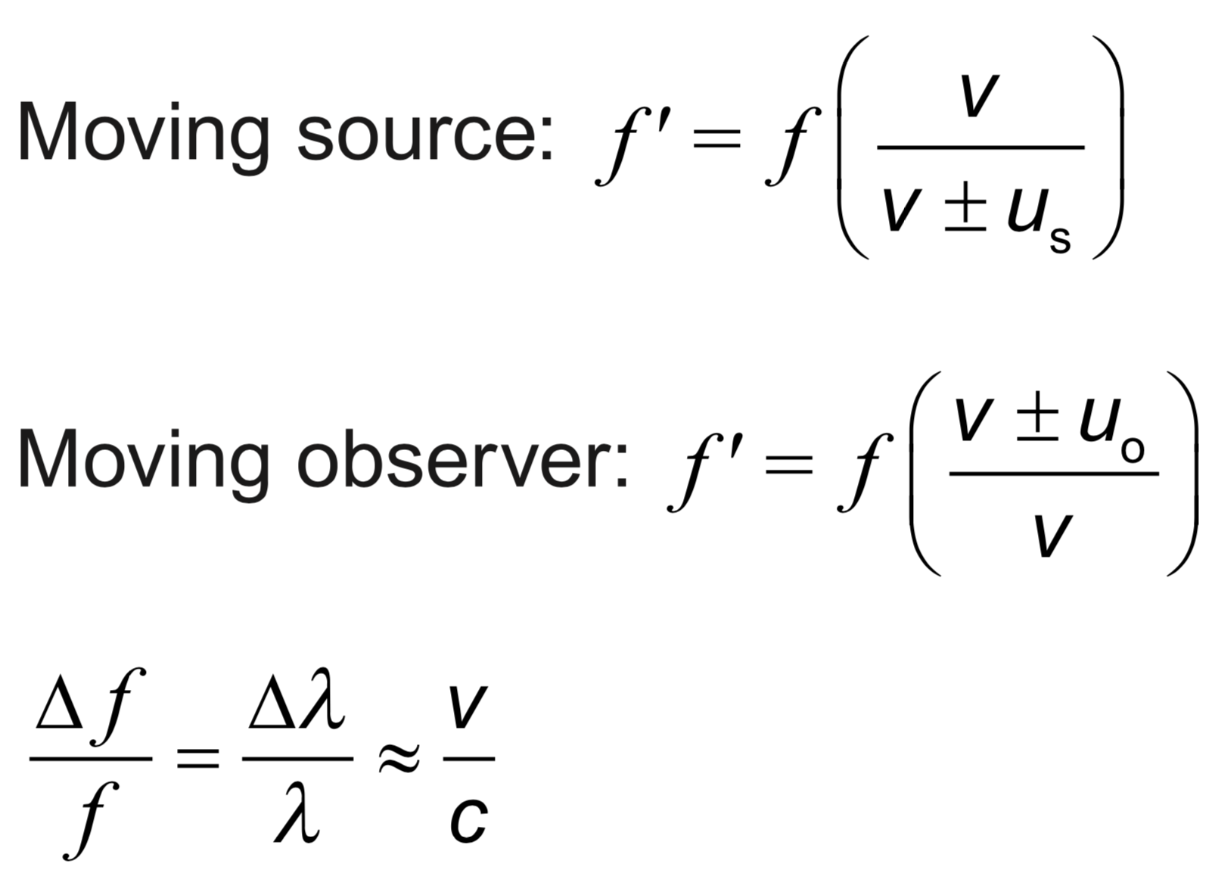 | Drawing/Diagram/Graph/Relationships

Topic 10: Fields (11 hours)
Syllabus dissection

Essential idea: Electric charges and masses each influence the space around them and that influence can be represented through the concept of fields.
10.1 – Describing fields
Nature of science:
Paradigm shift: The move from direct, observable actions being responsible for influence on an object to acceptance of a field’s “action at a distance” required a paradigm shift in the world of science. (2.3)

Topic 10: Fields
Understandings:  • Gravitational fields  • Electrostatic fields  • Electric potential and gravitational potential  • Field lines  • Equipotential surfaces  Applications and skills:  • Representing sources of mass and charge, lines of electric and gravitational force, and field patterns using an appropriate symbolism  • Mapping fields using potential  • Describing the connection between equipotential surfaces and field lines  Guidance:  • Electrostatic fields are restricted to the radial fields around point or spherical charges, the field between two point charges and the uniform fields between charged parallel plates  • Gravitational fields are restricted to the radial fields around point or spherical masses and the (assumed) uniform field close to the surface of massive celestial bodies and planetary bodies  • Students should recognize that no work is done in moving charge or mass on an equipotential surface  Data booklet reference:  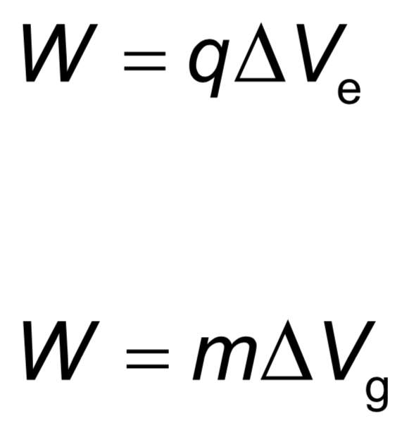 | Drawing/Diagram/Graph/Relationships

Essential idea: Similar approaches can be taken in analyzing electrical and gravitational potential problems.
10.2 – Fields at work
Nature of science:
Communication of scientific explanations: The ability to apply field theory to the unobservable (charges) and the massively scaled (motion of satellites) required scientists to develop new ways to investigate, analyse and report findings to a general public used to scientific discoveries based on tangible and discernible evidence. (5.1)

Understandings:  • Potential and potential energy  • Potential gradient  • Potential difference  • Escape speed  • Orbital motion, orbital speed and orbital energy  • Forces and inverse-square law behaviour  Applications and skills:  • Determining the potential energy of a point mass and the potential energy of a point charge  • Solving problems involving potential energy  • Determining the potential inside a charged sphere  • Solving problems involving the speed required for an object to go into orbit around a planet and for an object to escape the gravitational field of a planet  • Solving problems involving orbital energy of charged particles in circular orbital motion and masses in circular orbital motion  • Solving problems involving forces on charges and masses in radial and uniform fields  Guidance:  • Orbital motion of a satellite around a planet is restricted to a consideration of circular orbits (links to 6.1 and 6.2)  • Both uniform and radial fields need to be considered  • Students should recognize that lines of force can be two-dimensional representations of three-dimensional fields  • Students should assume that the electric field everywhere between parallel plates is uniform with edge effects occurring beyond the limits of the plates  Data booklet reference:  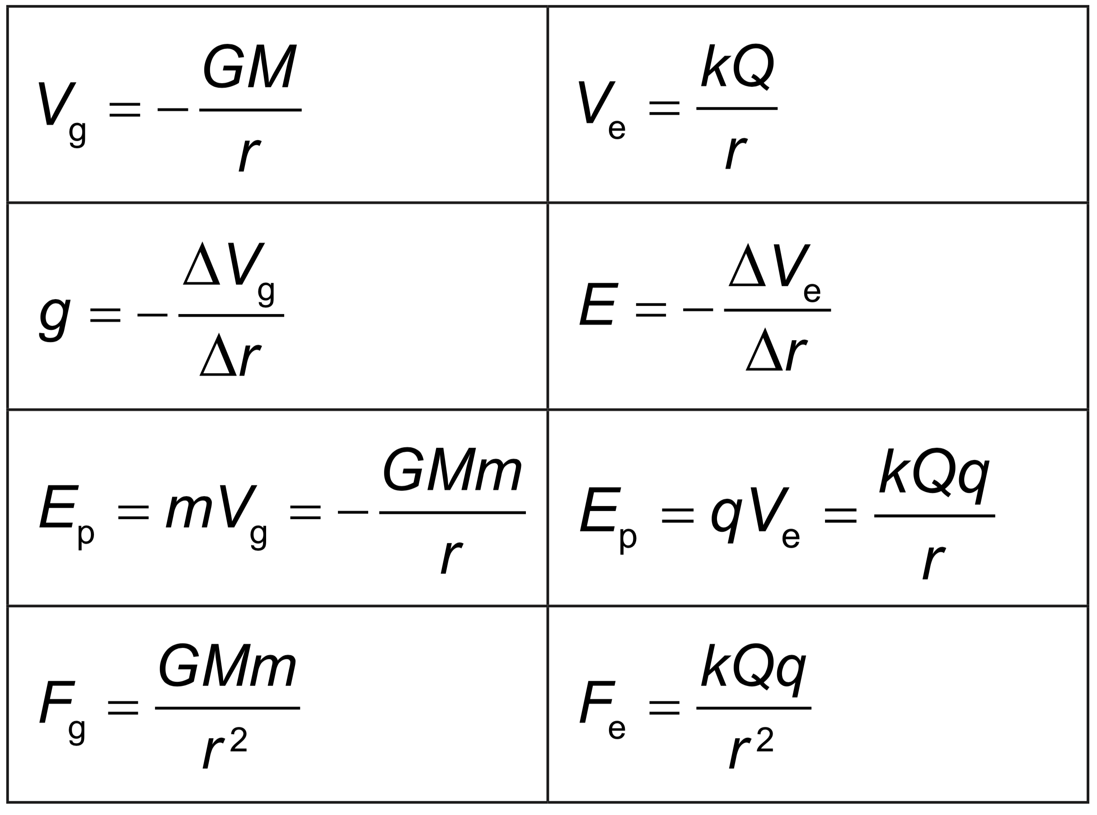 | 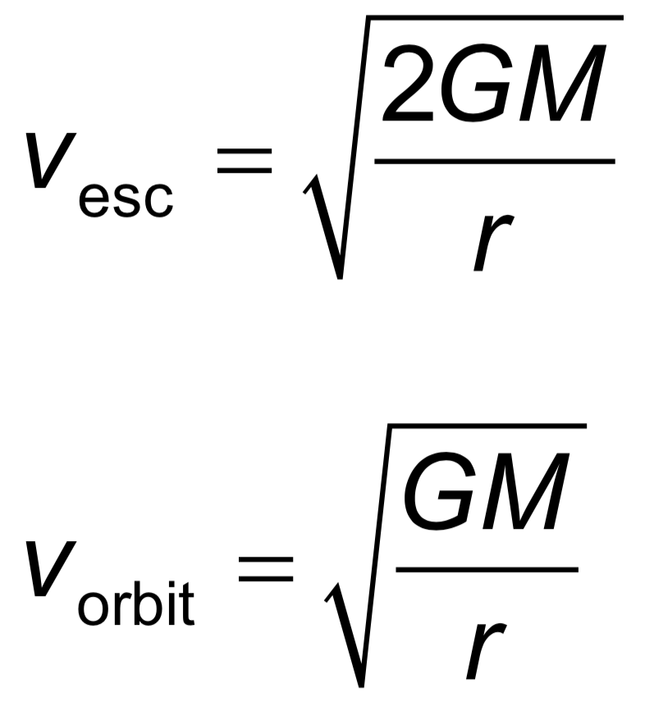  Drawing/Diagram/Graph/Relationships

Topic 11: Electromagnetic induction (16 hours)
Syllabus Dissection

Essential idea: The majority of electricity generated throughout the world is generated by machines that were designed to operate using the principles of electromagnetic induction.

11.1 – Electromagnetic induction

Nature of science:
Experimentation: In 1831 Michael Faraday, using primitive equipment, observed a minute pulse of current in one coil of wire only when the current in a second coil of wire was switched on or off but nothing while a constant current was established. Faraday’s observation of these small transient currents led him to perform experiments that led to his law of electromagnetic induction. (1.8)

Topic 11: Electromagnetic induction
Understandings:  • Emf  • Magnetic flux and magnetic flux linkage  • Faraday’s law of induction  • Lenz’s law  Applications and skills:  • Describing the production of an induced emf by a changing magnetic flux and within a uniform magnetic field  • Solving problems involving magnetic flux, magnetic flux linkage and Faraday’s law  • Explaining Lenz’s law through the conservation of energy  Guidance:  • Quantitative treatments will be expected for straight conductors moving at right angles to magnetic fields and rectangular coils moving in and out of fields and rotating in fields  • Qualitative treatments only will be expected for fixed coils in a changing magnetic field and ac generators  Data booklet reference:  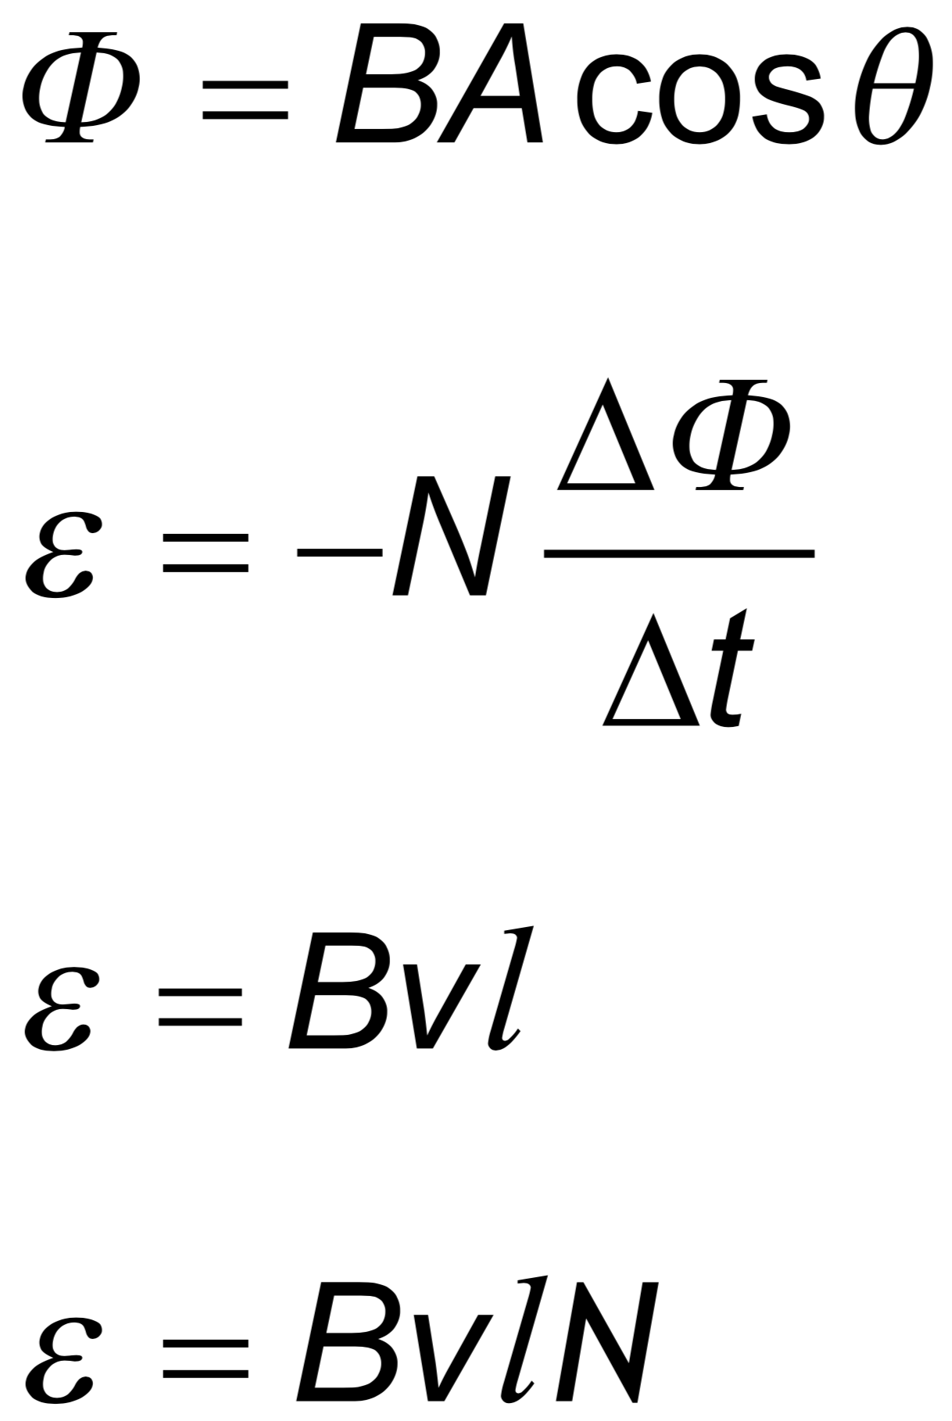 | Drawing/Diagram/Graph/Relationships

Essential idea: Generation and transmission of alternating current (ac) electricity has transformed the world.

11.2 – Power generation and transmission

Nature of science:
Bias: In the late 19th century Edison was a proponent of direct current electrical energy transmission while Westinghouse and Tesla favored alternating current transmission. The so called “battle of currents” had a significant impact on today’s society. (3.5)

Understandings:  • Alternating current (ac) generators  • Average power and root mean square (rms) values of current and voltage  • Transformers  • Diode bridges  • Half-wave and full-wave rectification  Applications and skills:  • Explaining the operation of a basic ac generator, including the effect of changing the generator frequency  • Solving problems involving the average power in an ac circuit  • Solving problems involving step-up and step-down transformers  • Describing the use of transformers in ac electrical power distribution  • Investigating a diode bridge rectification circuit experimentally  • Qualitatively describing the effect of adding a capacitor to a diode bridge rectification circuit  Guidance:  • Calculations will be restricted to ideal transformers but students should be aware of some of the reasons why real transformers are not ideal (for example: flux leakage, joule heating, eddy current heating, magnetic hysteresis)  • Proof of the relationship between the peak and rms values will not be expected  Data booklet reference:  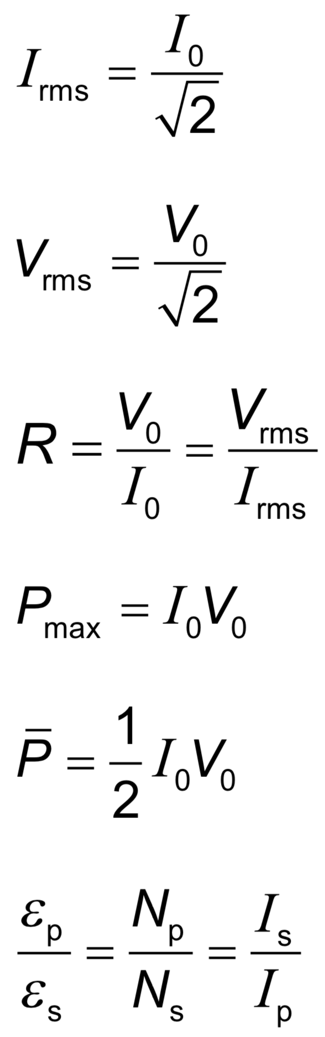 | Drawing/Diagram/Graph/Relationships

Essential idea: Capacitors can be used to store electrical energy for later use.

11.3 – Capacitance

Nature of science:
Relationships: Examples of exponential growth and decay pervade the whole of science. It is a clear example of the way that scientists use mathematics to model reality. This topic can be used to create links between physics topics but also to uses in chemistry, biology, medicine and economics. (3.1)

Understandings:  • Capacitance  • Dielectric materials  • Capacitors in series and parallel  • Resistor-capacitor (RC) series circuits  • Time constant  Applications and skills:  • Describing the effect of different dielectric materials on capacitance  • Solving problems involving parallel-plate capacitors  • Investigating combinations of capacitors in series or parallel circuits  • Determining the energy stored in a charged capacitor  • Describing the nature of the exponential discharge of a capacitor  • Solving problems involving the discharge of a capacitor through a fixed resistor  • Solving problems involving the time constant of an RC circuit for charge, voltage and current  Guidance:  • Only single parallel-plate capacitors providing a uniform electric field, in series with a load, need to be considered (edge effect will be neglected)  • Problems involving the discharge of capacitors through fixed resistors need to be treated both graphically and algebraically  • Problems involving the charging of a capacitor will only be treated graphically  • Derivation of the charge, voltage and current equations as a function of time is not required  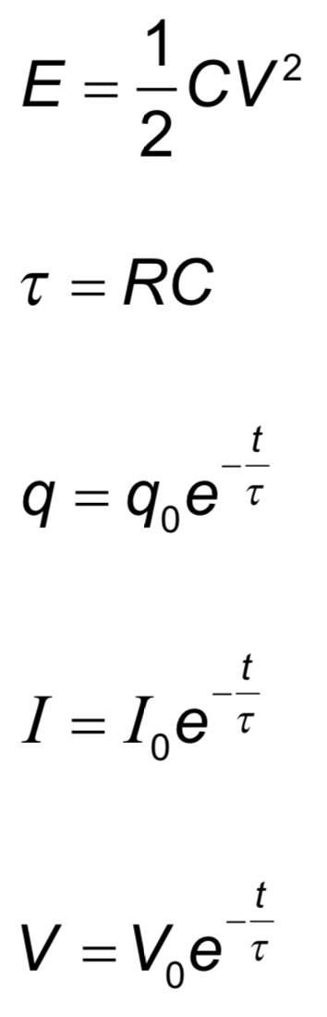  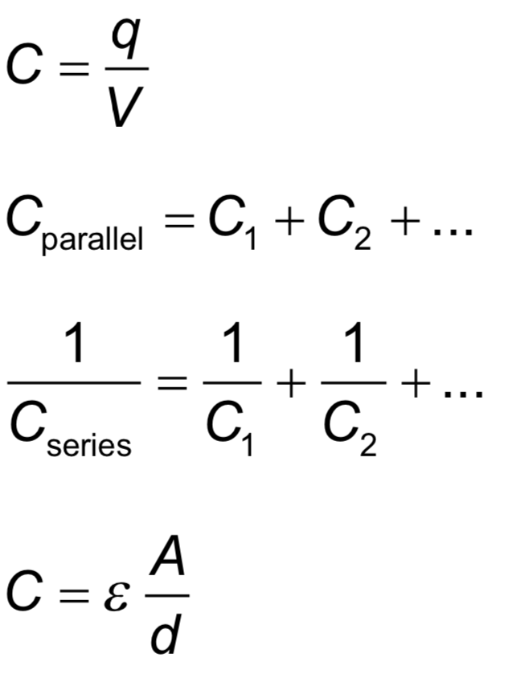  Data booklet reference: | Drawing/Diagram/Graph/Relationships

Topic 12: Quantum and nuclear physics (16 hours)
Syllabus dissection

Essential idea: The microscopic quantum world offers a range of phenomena, the interpretation and explanation of which require new ideas and concepts not found in the classical world.
12.1 – The interaction of matter with radiation
Nature of science:
Observations: Much of the work towards a quantum theory of atoms was guided by the need to explain the observed patterns in atomic spectra. The first quantum model of matter is the Bohr model for hydrogen. (1.8)

Paradigm shift: The acceptance of the wave–particle duality paradox for light and particles required scientists in many fields to view research from new perspectives. (2.3)

Topic 12: Quantum and nuclear physics
Understandings:  • Photons  • The photoelectric effect  • Matter waves  • Pair production and pair annihilation  • Quantization of angular momentum in the Bohr model for hydrogen  • The wave function  • The uncertainty principle for energy and time and position and momentum  • Tunnelling, potential barrier and factors affecting tunnelling probability  Applications and skills:  • Discussing the photoelectric effect experiment and explaining which features of the experiment cannot be explained by the classical wave theory of light  • Solving photoelectric problems both graphically and algebraically  • Discussing experimental evidence for matter waves, including an experiment in which the wave nature of electrons is evident  • Stating order of magnitude estimates from the uncertainty principle  Guidance:  • The order of magnitude estimates from the uncertainty principle may include (but is not limited to) estimates of the energy of the ground state of an atom, the impossibility of an electron existing within a nucleus, and the lifetime of an electron in an excited energy state  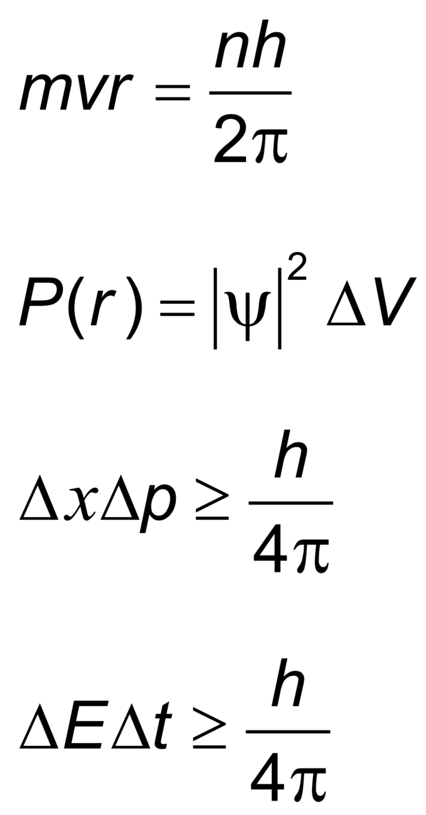  • Tunnelling to be treated qualitatively using the idea of continuity of wave functions  Data booklet reference:  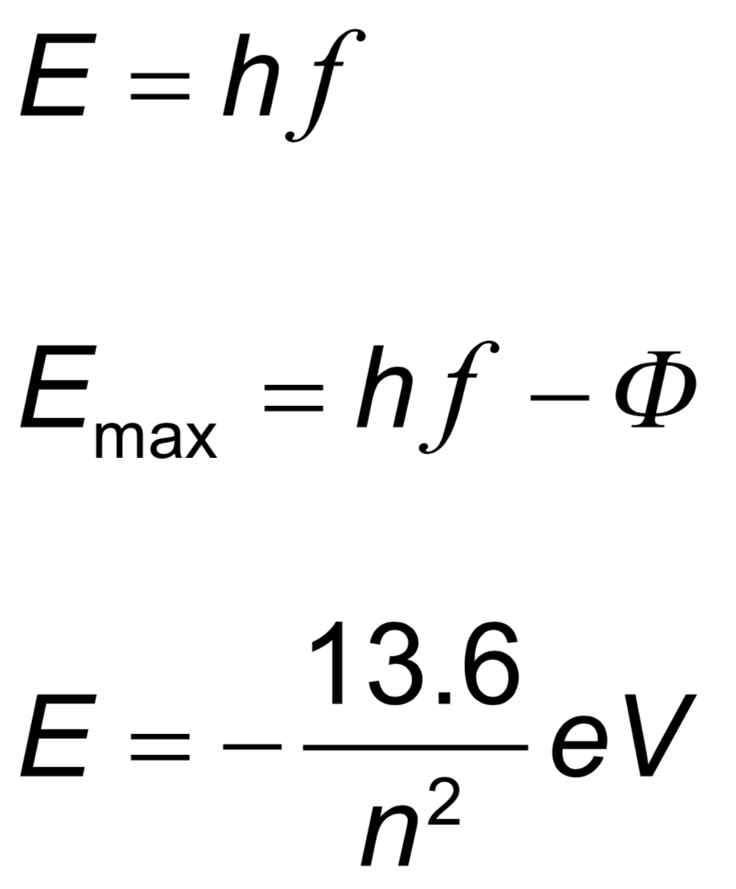 | Drawing/Diagram/Graph/Relationships

Essential idea: The idea of discreteness that we met in the atomic world continues to exist in the nuclear world as well.
12.2 – Nuclear physics
Nature of science:
Theoretical advances and inspiration: Progress in atomic, nuclear and particle physics often came from theoretical advances and strokes of inspiration.
Advances in instrumentation: New ways of detecting subatomic particles due to advances in electronic technology were also crucial.
Modern computing power: Finally, the analysis of the data gathered in modern particle detectors in particle accelerator experiments would be impossible without modern computing power. (1.8)

Understandings:  • Rutherford scattering and nuclear radius  • Nuclear energy levels  • The neutrino  • The law of radioactive decay and the decay constant  Applications and skills:  • Describing a scattering experiment including location of minimum intensity for the diffracted particles based on their de Broglie wavelength  • Explaining deviations from Rutherford scattering in high energy experiments  • Describing experimental evidence for nuclear energy levels  • Solving problems involving the radioactive decay law for arbitrary time intervals  • Explaining the methods for measuring short and long half-lives  Guidance:  • Students should be aware that nuclear densities are approximately the same for all nuclei and that the only macroscopic objects with the same density as nuclei are neutron stars  • The small angle approximation is usually not appropriate to use to determine the location of the minimum intensity  Data booklet reference:  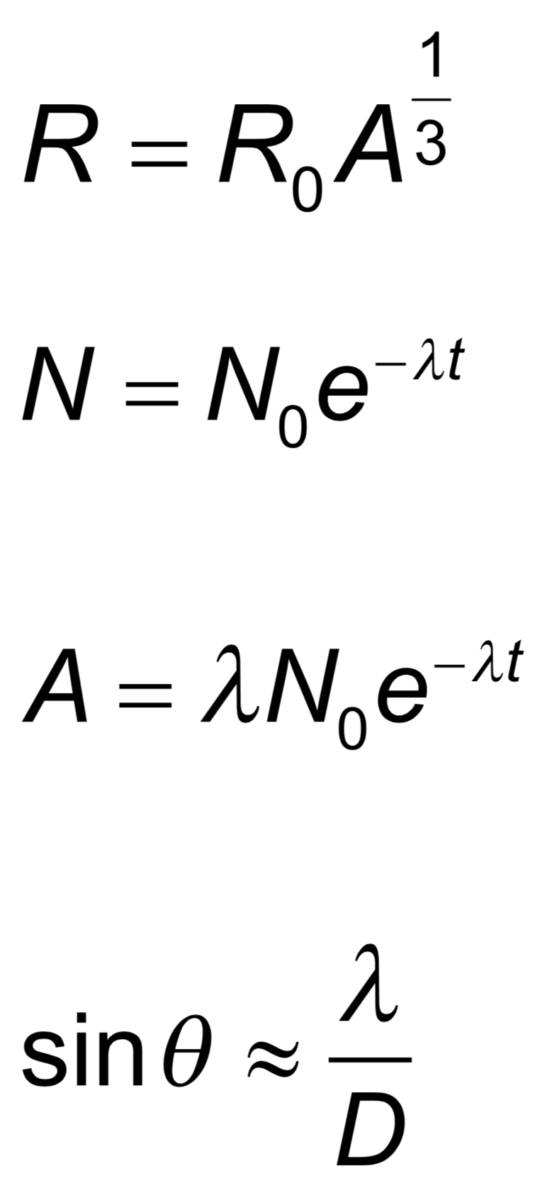 | Drawing/Diagram/Graph/Relationships

Option A: Relativity (15 + 10 hours)
Syllabus dissection

Essential idea: Einstein’s study of electromagnetism revealed inconsistencies between the theory of Maxwell and Newton‘s mechanics. He recognized that both theories could not be reconciled and so choosing to trust Maxwell’s theory of electromagnetism he was forced to change long-cherished ideas about space and time in mechanics.
A.1 – The beginnings of relativity
Nature of science:
Paradigm shift: The fundamental fact that the speed of light is constant for all inertial observers has far-reaching consequences about our understanding of space and time. Ideas about space and time that went unchallenged for more than 2,000 years were shown to be false. The extension of the principle of relativity to accelerated frames of reference leads to the revolutionary idea of general relativity that the mass and energy that spacetime contains determine the geometry of spacetime. (2.3)

Option A: Relativity
Understandings:  • Reference frames  • Galilean relativity and Newton’s postulates concerning time and space  • Maxwell and the constancy of the speed of light  • Forces on a charge or current  Applications and skills:  • Using the Galilean transformation equations  • Determining whether a force on a charge or current is electric or magnetic in a given frame of reference  • Determining the nature of the fields observed by different observers  Guidance:  • Maxwell’s equations do not need to be described  • Qualitative treatment of electric and magnetic fields as measured by observers in relative motion. Examples will include a charge moving in a magnetic field or two charged particles moving with parallel velocities. Students will be asked to analyse these motions from the point of view of observers at rest with respect to the particles and observers at rest with respect to the magnetic field.  Data booklet reference:  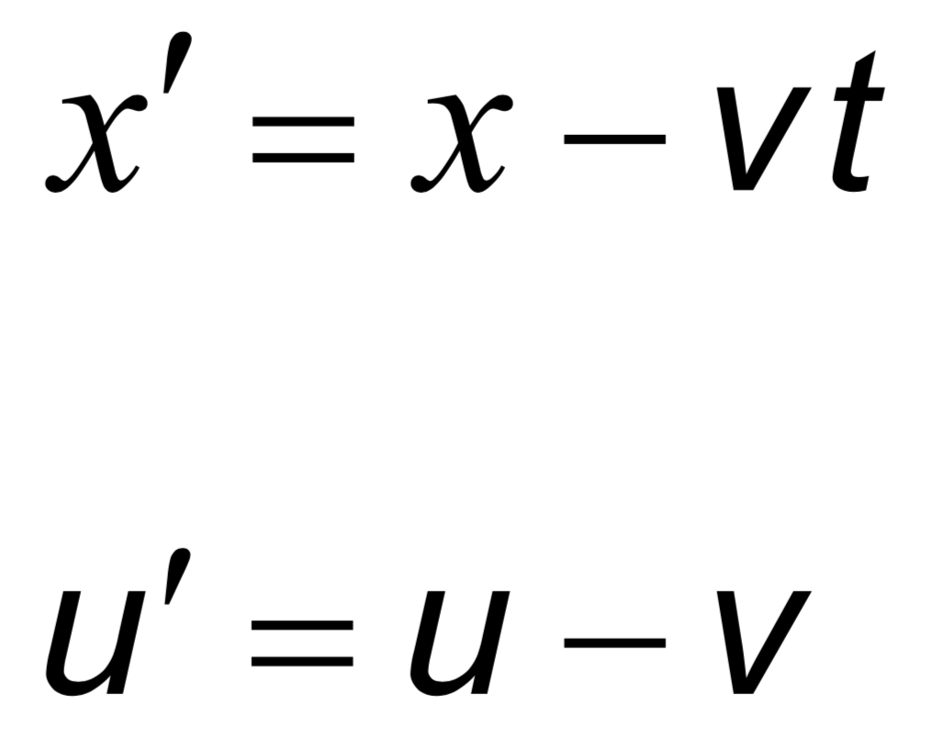 | Drawing/Diagram/Graph/Relationships

Essential idea: Observers in relative uniform motion disagree on the numerical values of space and time coordinates for events, but agree with the numerical value of the speed of light in a vacuum. The Lorentz transformation equations relate the values in one reference frame to those in another. These equations replace the Galilean transformation equations that fail for speeds close to that of light.
A.2 – Lorentz transformations
Nature of science:
Pure science: Einstein based his theory of relativity on two postulates and deduced the rest by mathematical analysis. The first postulate integrates all of the laws of physics including the laws of electromagnetism, not only Newton’s laws of mechanics. (1.2)

Understandings:  • The two postulates of special relativity  • Clock synchronization  • The Lorentz transformations  • Velocity addition  • Invariant quantities (spacetime interval, proper time, proper length and rest mass)  • Time dilation  • Length contraction  • The muon decay experiment  Applications and skills:  • Using the Lorentz transformations to describe how different measurements of space and time by two observers can be converted into the measurements observed in either frame of reference  • Using the Lorentz transformation equations to determine the position and time coordinates of various events  • Using the Lorentz transformation equations to show that if two events are simultaneous for one observer but happen at different points in space, then the events are not simultaneous for an observer in a different reference frame  • Solving problems involving velocity addition  • Deriving the time dilation and length contraction equations using the Lorentz equations  • Solving problems involving time dilation and length contraction  • Solving problems involving the muon decay experiment  Guidance:  • Problems will be limited to one dimension  • Derivation of the Lorentz transformation equations will not be examined  • Muon decay experiments can be used as evidence for both time dilation and length contraction  Data booklet reference: | 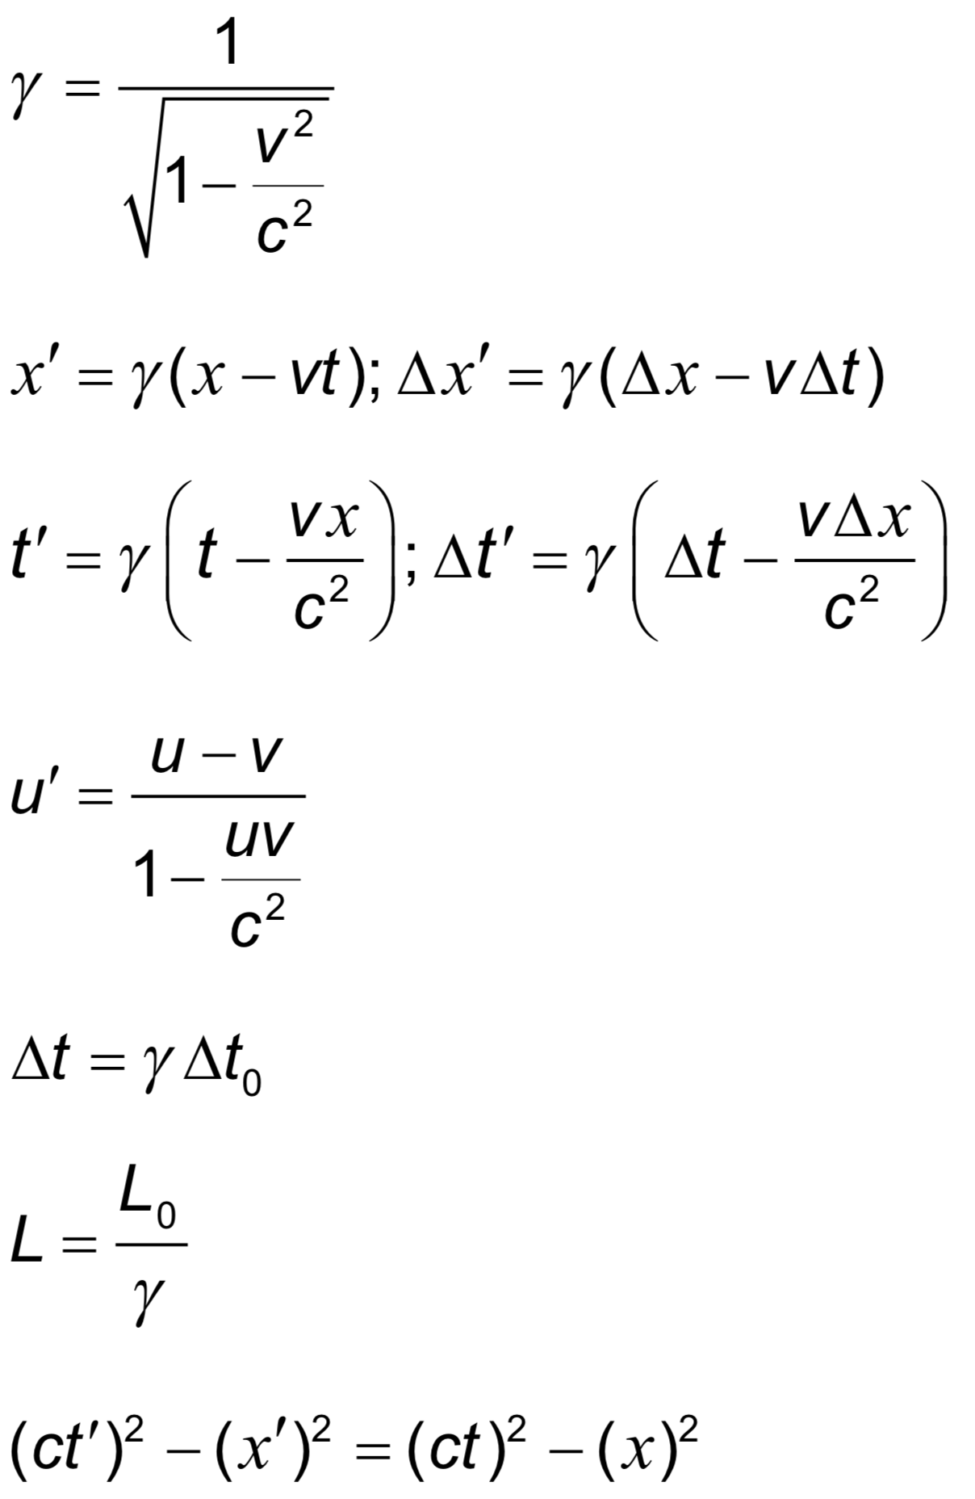  Drawing/Diagram/Graph/Relationships

Essential idea: Spacetime diagrams are a very clear and illustrative way to show graphically how different observers in relative motion to each other have measurements that differ from each other.
A.3 – Spacetime diagrams
Nature of science:
Visualization of models: The visualization of the description of events in terms of spacetime diagrams is an enormous advance in understanding the concept of spacetime. (1.10)

Understandings:  • Spacetime diagrams  • Worldlines  • The twin paradox  Applications and skills:  • Representing events on a spacetime diagram as points  • Representing the positions of a moving particle on a spacetime diagram by a curve (the worldline)  • Representing more than one inertial reference frame on the same spacetime diagram  • Determining the angle between a worldline for specific speed and the time axis on a spacetime diagram  • Solving problems on simultaneity and kinematics using spacetime diagrams  • Representing time dilation and length contraction on spacetime diagrams  • Describing the twin paradox  • Resolving of the twin paradox through spacetime diagrams  Guidance:  • Examination questions will refer to spacetime diagrams; these are also known as Minkowski diagrams  • Quantitative questions involving spacetime diagrams will be limited to constant velocity  • Spacetime diagrams can have t or ct on the vertical axis  • Examination questions may use units in which c = 1  Data booklet reference:  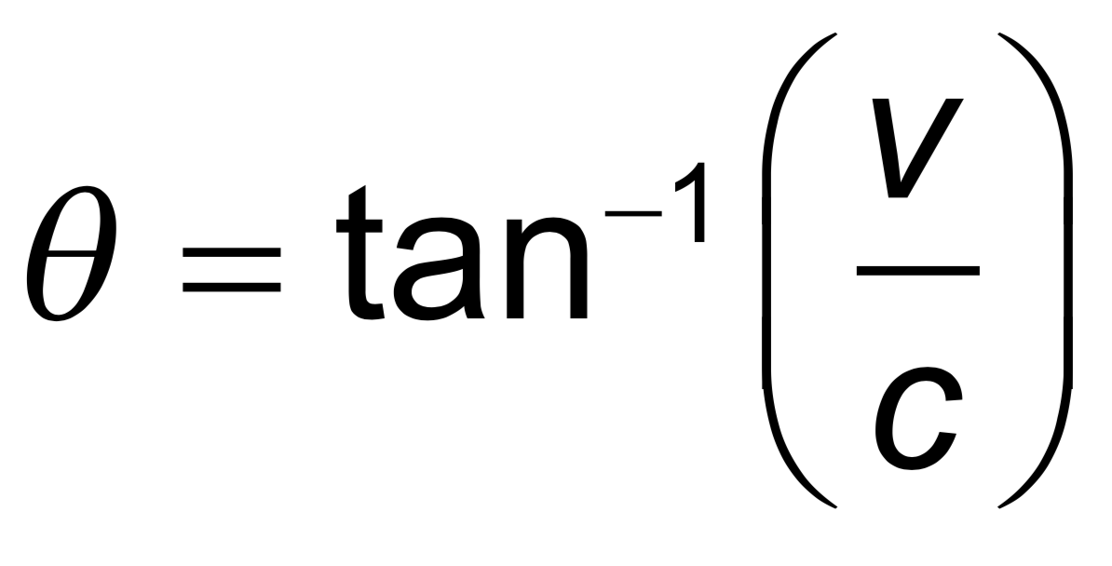 | Drawing/Diagram/Graph/Relationships

Essential idea: The relativity of space and time requires new definitions for energy and momentum in order to preserve the conserved nature of these laws.
A.4 – Relativistic mechanics (AHL)
Nature of science:
Paradigm shift: Einstein realized that the law of conservation of momentum could not be maintained as a law of physics. He therefore deduced that in order for momentum to be conserved under all conditions, the definition of momentum had to change and along with it the definitions of other mechanics quantities such as kinetic energy and total energy of a particle. This was a major paradigm shift. (2.3)

Understandings:  • Total energy and rest energy  • Relativistic momentum  • Particle acceleration  • Electric charge as an invariant quantity  • Photons  • MeV c–2 as the unit of mass and MeV c–1 as the unit of momentum  Applications and skills:  • Describing the laws of conservation of momentum and conservation of energy within special relativity  • Determining the potential difference necessary to accelerate a particle to a given speed or energy  • Solving problems involving relativistic energy and momentum conservation in collisions and particle decays  Guidance:  • Applications will involve relativistic decays such as calculating the wavelengths of photons in the decay of a moving pion [$π°→2γ$]  • The symbol m₀ refers to the invariant rest mass of a particle  • The concept of a relativistic mass that varies with speed will not be used  • Problems will be limited to one dimension  Data booklet reference:  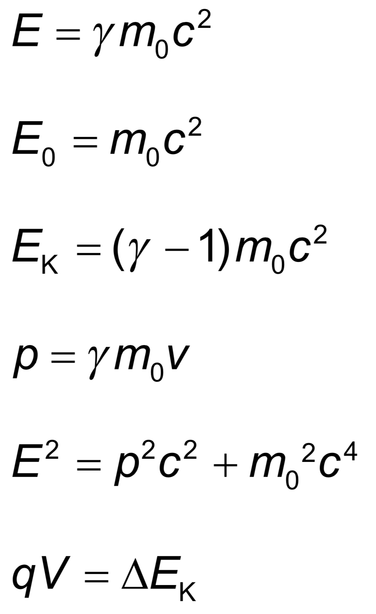 | Drawing/Diagram/Graph/Relationships

Essential idea: General relativity is applied to bring together fundamental concepts of mass, space and time in order to describe the fate of the universe.
A.5 – General relativity (AHL)
Nature of science:
Creative and critical thinking: Einstein’s great achievement, the general theory of relativity, is based on intuition, creative thinking and imagination, namely to connect the geometry of spacetime (through its curvature) to the mass and energy content of spacetime. For years it was thought that nothing could escape a black hole and this is true but only for classical black holes. When quantum theory is taken into account a black hole radiates like a black body. This unexpected result revealed other equally unexpected connections between black holes and thermodynamics. (1.4)

Understandings:  • The equivalence principle  • The bending of light  • Gravitational redshift and the Pound–Rebka–Snider experiment  • Schwarzschild black holes  • Event horizons  • Time dilation near a black hole  • Applications of general relativity to the universe as a whole  Applications and skills:  • Using the equivalence principle to deduce and explain light bending near massive objects  • Using the equivalence principle to deduce and explain gravitational time dilation  • Calculating gravitational frequency shifts  • Describing an experiment in which gravitational redshift is observed and measured  • Calculating the Schwarzschild radius of a black hole  • Applying the formula for gravitational time dilation near the event horizon of a black hole  Guidance:  • Students should recognize the equivalence principle in terms of accelerating reference frames and freely falling frames  Data booklet reference:  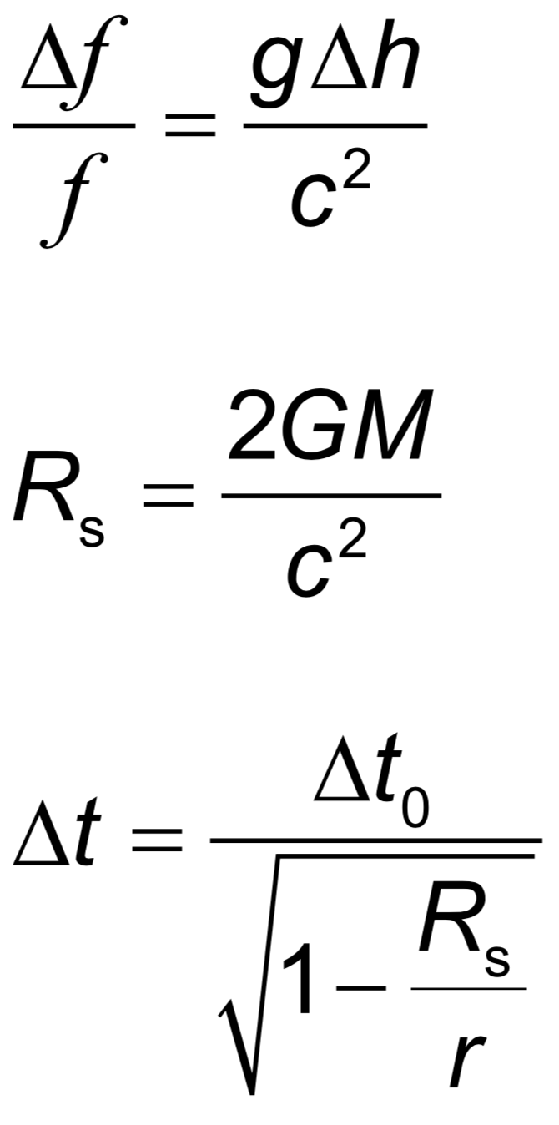 | Drawing/Diagram/Graph/Relationships

Option B: Engineering physics (15 + 10 hours)
Syllabus dissection

Essential idea: The basic laws of mechanics have an extension when equivalent principles are applied to rotation. Actual objects have dimensions and they require the expansion of the point particle model to consider the possibility of different points on an object having different states of motion and/or different velocities.
B.1 – Rigid bodies and rotational dynamics
Nature of science:
Modelling: The use of models has different purposes and has allowed scientists to identify, simplify and analyse a problem within a given context to tackle it successfully. The extension of the point particle model to actually consider the dimensions of an object led to many groundbreaking developments in engineering. (1.2)

Option B: Engineering physics
Understandings:  • Torque  • Moment of inertia  • Rotational and translational equilibrium  • Angular acceleration  • Equations of rotational motion for uniform angular acceleration  • Newton’s second law applied to angular motion  • Conservation of angular momentum  Applications and skills:  • Calculating torque for single forces and couples  • Solving problems involving moment of inertia, torque and angular acceleration  • Solving problems in which objects are in both rotational and translational equilibrium  • Solving problems using rotational quantities analogous to linear quantities  • Sketching and interpreting graphs of rotational motion  • Solving problems involving rolling without slipping  Guidance:  • Analysis will be limited to basic geometric shapes  • The equation for the moment of inertia of a specific shape will be provided when necessary  • Graphs will be limited to angular displacement–time, angular velocity–time and torque–time  Data booklet reference: | 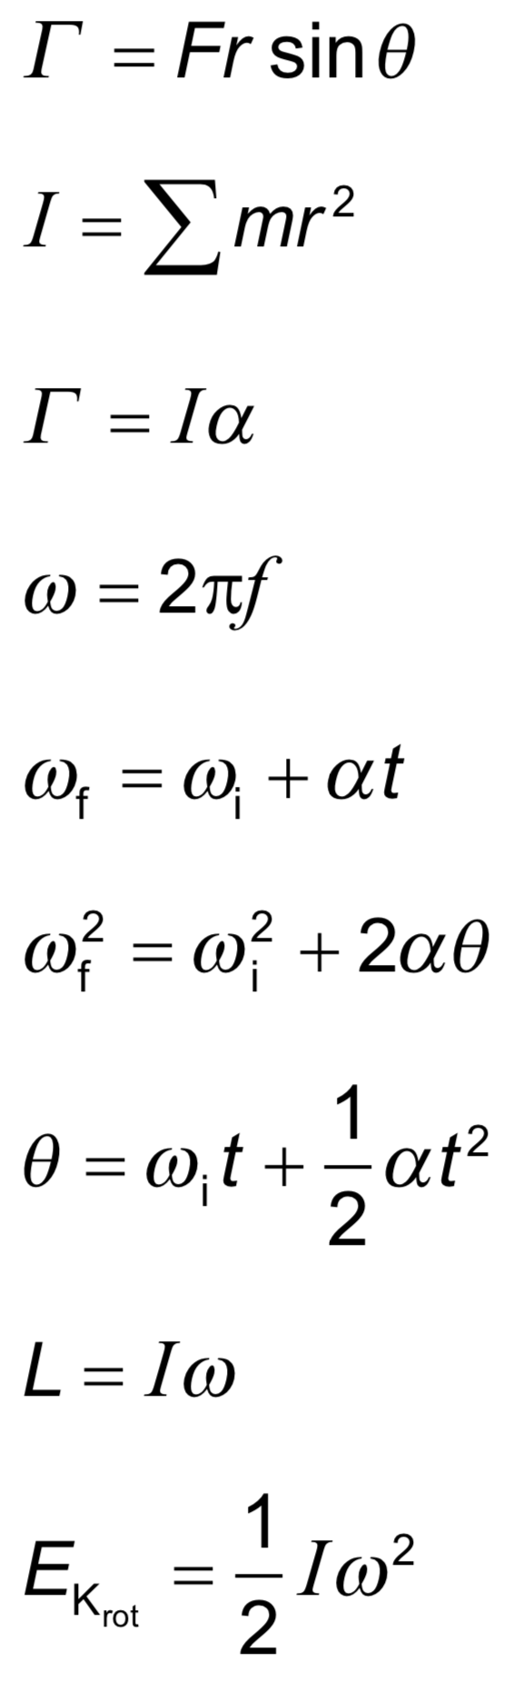  Drawing/Diagram/Graph/Relationships

Essential idea: The first law of thermodynamics relates the change in internal energy of a system to the energy transferred and the work done. The entropy of the universe tends to a maximum.
B.2 – Thermodynamics
Nature of science:
Variety of perspectives: With three alternative and equivalent statements of the second law of thermodynamics, this area of physics demonstrates the collaboration and testing involved in confirming abstract notions such as this. (4.1)

Understandings:  • The first law of thermodynamics  • The second law of thermodynamics  • Entropy  • Cyclic processes and pV diagrams  • Isovolumetric, isobaric, isothermal and adiabatic processes  • Carnot cycle  • Thermal efficiency  Applications and skills:  • Describing the first law of thermodynamics as a statement of conservation of energy  • Explaining sign convention used when stating the first law of thermodynamics as Q = ΔU +W  • Solving problems involving the first law of thermodynamics  • Describing the second law of thermodynamics in Clausius form, Kelvin form and as a consequence of entropy  • Describing examples of processes in terms of entropy change  • Solving problems involving entropy changes  • Sketching and interpreting cyclic processes  • Solving problems for adiabatic processes for monatomic gases using $p^{\frac{5}{3}}=constant$  • Solving problems involving thermal efficiency  Guidance:  • If cycles other than the Carnot cycle are used quantitatively, full details will be provided  • Only graphical analysis will be required for determination of work done on a pV diagram when pressure is not constant  Data booklet reference: | 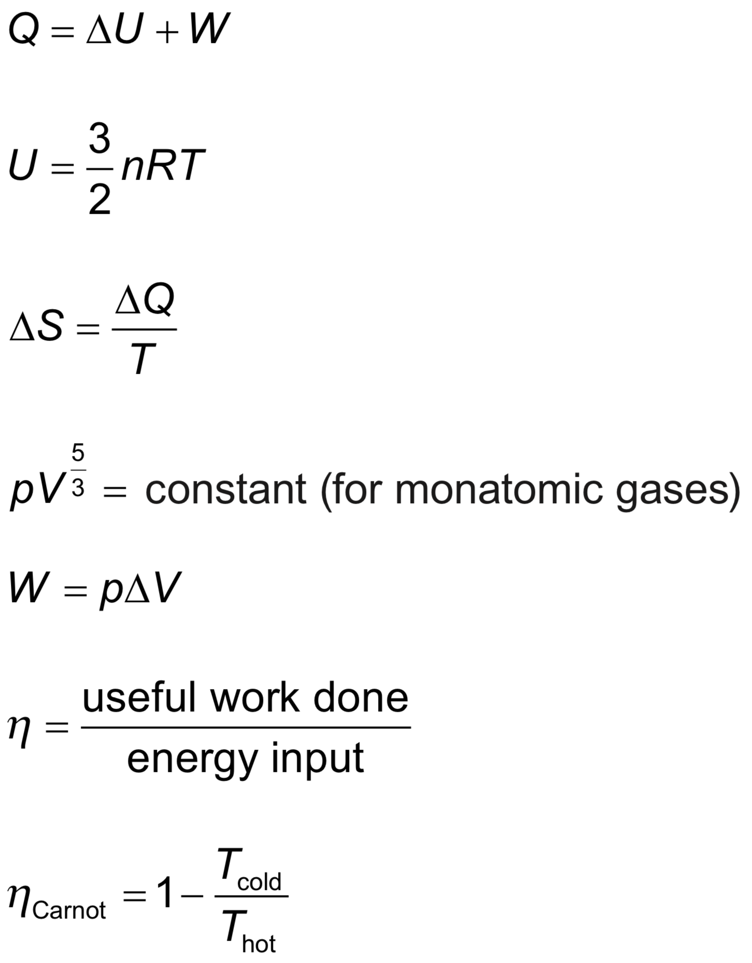  Drawing/Diagram/Graph/Relationships

Essential idea: Fluids cannot be modelled as point particles. Their distinguishable response to compression from solids creates a set of characteristics that require an indepth study.
B.3 – Fluids and fluid dynamics (AHL)
Nature of science:
Human understandings: Understanding and modelling fluid flow has been important in many technological developments such as designs of turbines, aerodynamics of cars and aircraft, and measurement of blood flow. (1.1)

Understandings:  • Density and pressure  • Buoyancy and Archimedes’ principle  • Pascal’s principle  • Hydrostatic equilibrium  • The ideal fluid  • Streamlines  • The continuity equation  • The Bernoulli equation and the Bernoulli effect  • Stokes’ law and viscosity  • Laminar and turbulent flow and the Reynolds number  Applications and skills:  • Determining buoyancy forces using Archimedes’ principle  • Solving problems involving pressure, density and Pascal’s principle  • Solving problems using the Bernoulli equation and the continuity equation  • Explaining situations involving the Bernoulli effect  • Describing the frictional drag force exerted on small spherical objects in laminar fluid flow  • Solving problems involving Stokes’ law  • Determining the Reynolds number in simple situations  Guidance:  • Ideal fluids will be taken to mean fluids that are incompressible and nonviscous and have steady flows  • Applications of the Bernoulli equation will involve (but not be limited to) flow out of a container, determining the speed of a plane (pitot tubes), and venture tubes  • Proof of the Bernoulli equation will not be required for examination purposes  • Laminar and turbulent flow will only be considered in simple situations  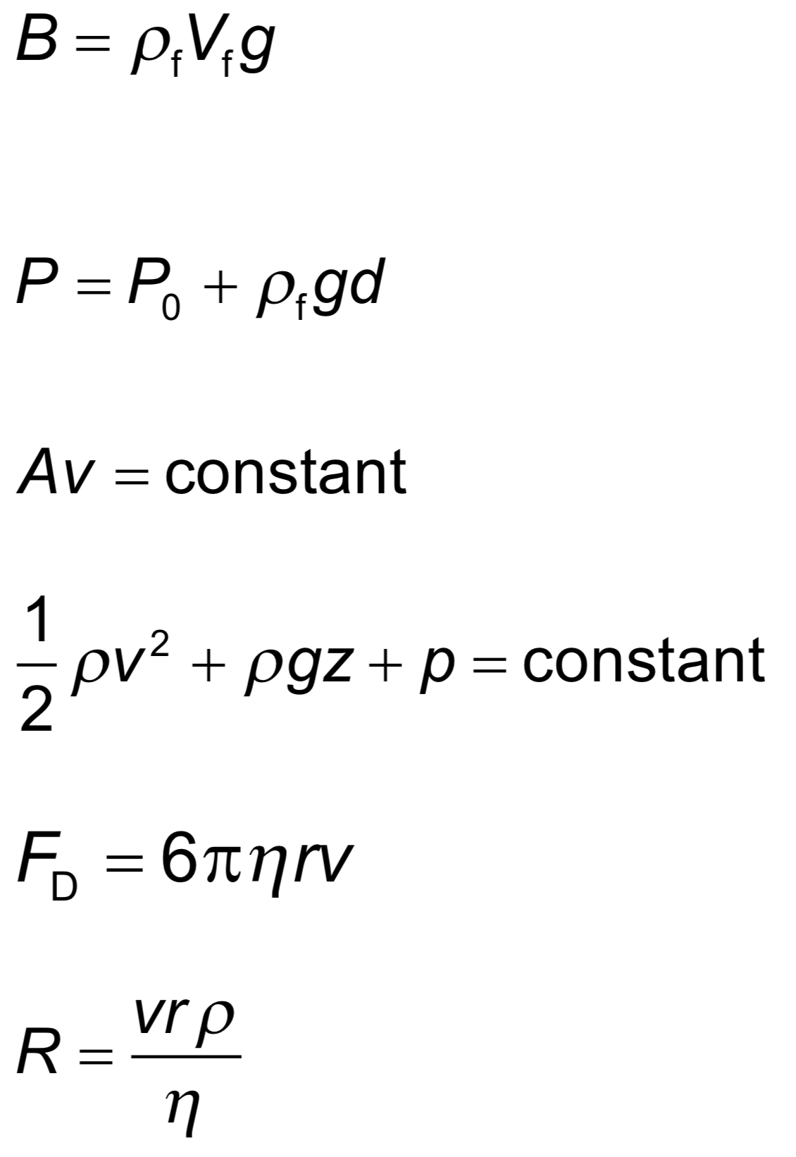  • Values of R <10³ will be taken to represent conditions for laminar flow  Data booklet reference: | Drawing/Diagram/Graph/Relationships

Essential idea: In the real world, damping occurs in oscillators and has implications that need to be considered.
B.4 – Forced vibrations and resonance (AHL)
Nature of science:
Risk assessment: The ideas of resonance and forced oscillation have application in many areas of engineering ranging from electrical oscillation to the safe design of civil structures. In large-scale civil structures, modelling all possible effects is essential before construction. (4.8)

Understandings:  • Natural frequency of vibration  • Q factor and damping  • Periodic stimulus and the driving frequency  • Resonance  Applications and skills:  • Qualitatively and quantitatively describing examples of under-, over- and critically-damped oscillations  • Graphically describing the variation of the amplitude of vibration with driving frequency of an object close to its natural frequency of vibration  • Describing the phase relationship between driving frequency and forced oscillations  • Solving problems involving Q factor  • Describing the useful and destructive effects of resonance  Guidance:  • Only amplitude resonance is required  Data booklet reference:  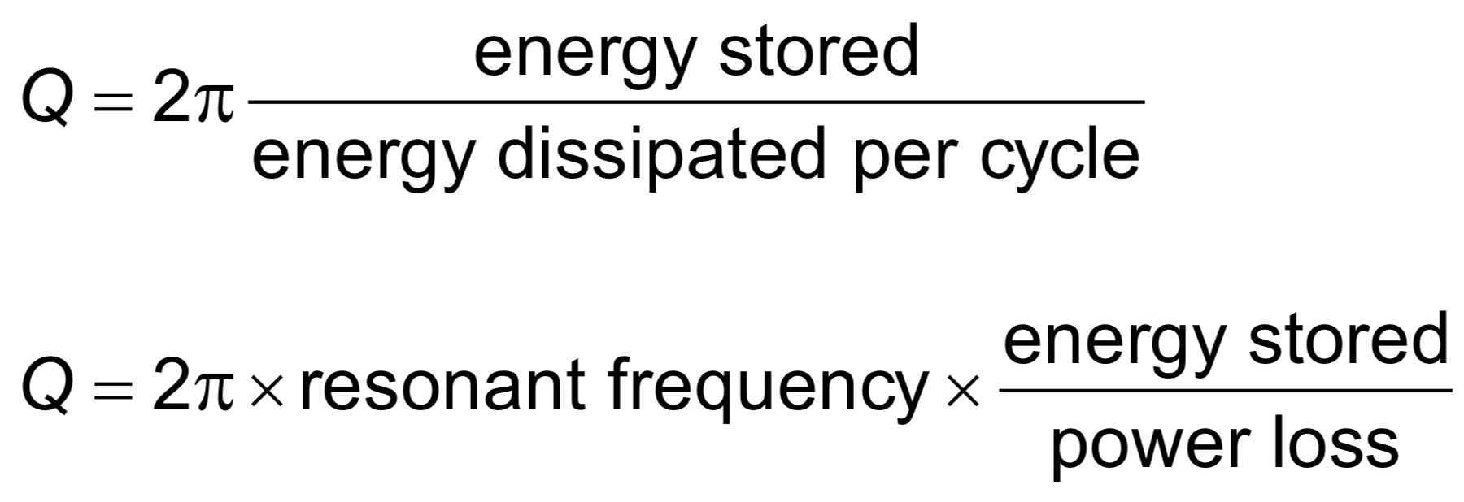 | Drawing/Diagram/Graph/Relationships

Option C: Imaging (15 + 10 hours)
Syllabus dissection

Essential idea: The progress of a wave can be modelled via the ray or the wavefront. The change in wave speed when moving between media changes the shape of the wave.
C.1 – Introduction to imaging
Nature of science:
Deductive logic: The use of virtual images is essential for our analysis of lenses and mirrors. (1.6)

Option C: Imaging
Understandings:  • Thin lenses  • Converging and diverging lenses  • Converging and diverging mirrors  • Ray diagrams  • Real and virtual images  • Linear and angular magnification  • Spherical and chromatic aberrations  Applications and skills:  • Describing how a curved transparent interface modifies the shape of an incident wavefront  • Identifying the principal axis, focal point and focal length of a simple converging or diverging lens on a scaled diagram  • Solving problems involving not more than two lenses by constructing scaled ray diagrams  • Solving problems involving not more than two curved mirrors by constructing scaled ray diagrams  • Solving problems involving the thin lens equation, linear magnification and angular magnification  • Explaining spherical and chromatic aberrations and describing ways to reduce their effects on images  Guidance:  • Students should treat the passage of light through lenses from the standpoint of both rays and wavefronts  • Curved mirrors are limited to spherical and parabolic converging mirrors and spherical diverging mirrors  • Only thin lenses are to be considered in this topic  • The lens-maker’s formula is not required  • Sign convention used in examinations will be based on real being positive (the “real-is-positive” convention)  Data booklet reference: | 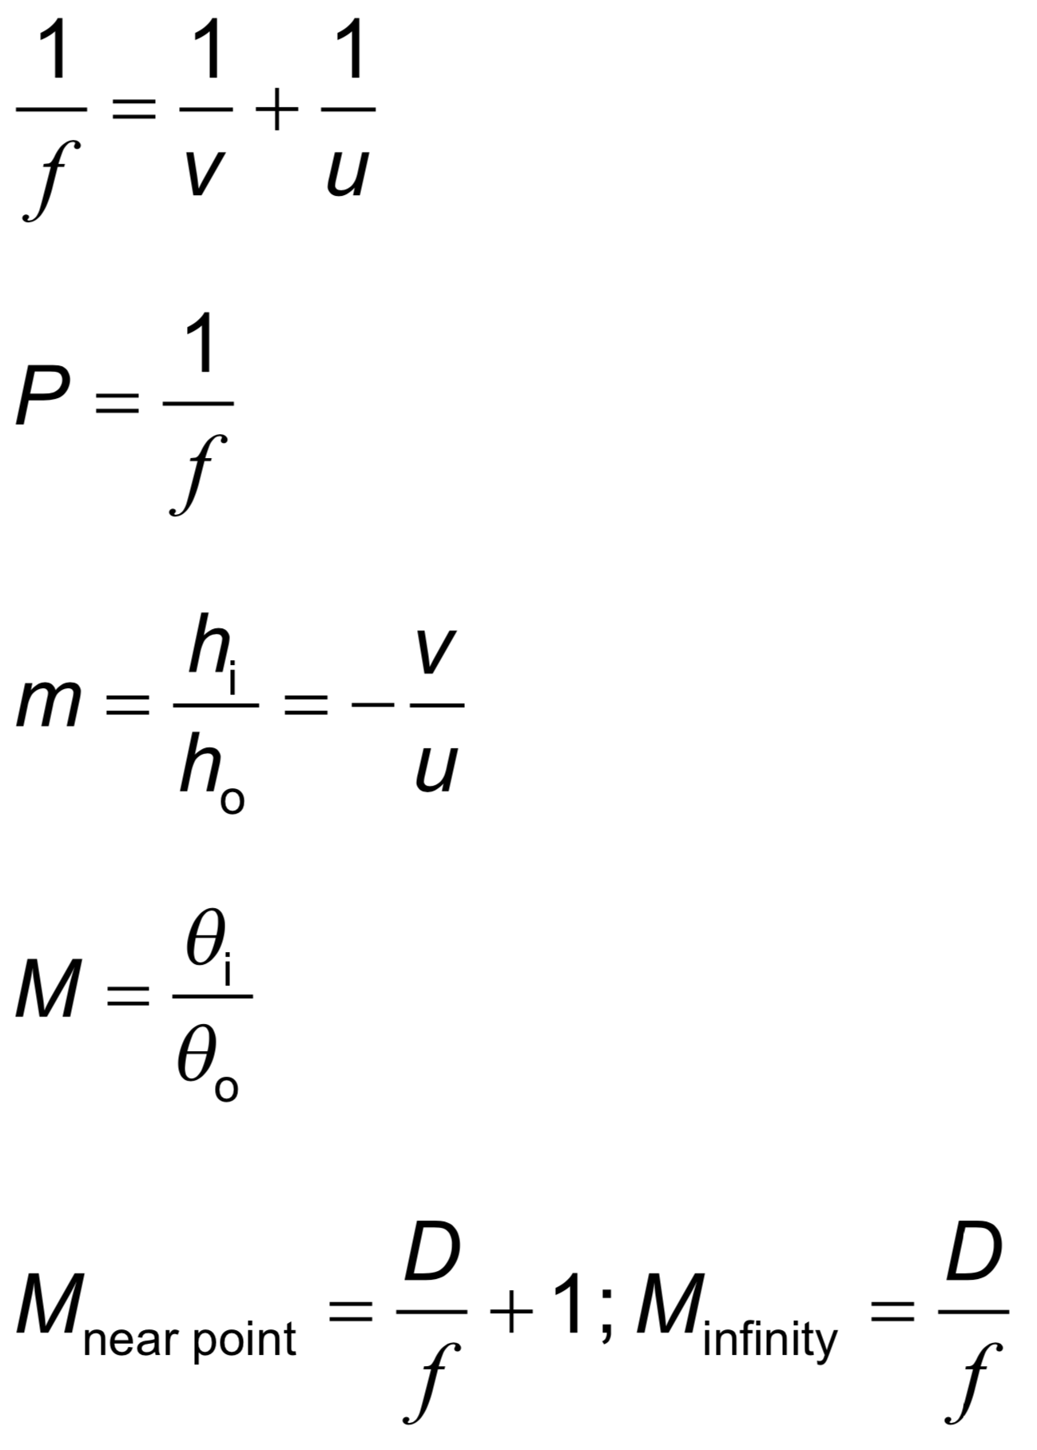  Drawing/Diagram/Graph/Relationships

Essential idea: Optical microscopes and telescopes utilize similar physical properties of lenses and mirrors. Analysis of the universe is performed both optically and by using radio telescopes to investigate different regions of the electromagnetic spectrum.
C.2 – Imaging instrumentation
Nature of science:
Improved instrumentation: The optical telescope has been in use for over 500 years. It has enabled humankind to observe and hypothesize about the universe. More recently, radio telescopes have been developed to investigate the electromagnetic radiation beyond the visible region. Telescopes (both visual and radio) are now placed away from the Earth’s surface to avoid the image degradation caused by the atmosphere, while corrective optics are used to enhance images collected at the Earth’s surface. Many satellites have been launched with sensors capable of recording vast amounts of data in the infrared, ultraviolet, X-ray and other electromagnetic spectrum ranges. (1.8)

Understandings:  • Optical compound microscopes  • Simple optical astronomical refracting telescopes  • Simple optical astronomical reflecting telescopes  • Single-dish radio telescopes  • Radio interferometry telescopes  • Satellite-borne telescopes  Applications and skills:  • Constructing and interpreting ray diagrams of optical compound microscopes at normal adjustment  • Solving problems involving the angular magnification and resolution of optical compound microscopes  • Investigating the optical compound microscope experimentally  • Constructing or completing ray diagrams of simple optical astronomical refracting telescopes at normal adjustment  • Solving problems involving the angular magnification of simple optical astronomical telescopes  • Investigating the performance of a simple optical astronomical refracting telescope experimentally  • Describing the comparative performance of Earth-based telescopes and satellite-borne telescopes  Guidance:  • Simple optical astronomical reflecting telescope design is limited to Newtonian and Cassegrain mounting  • Radio interferometer telescopes should be approximated as a dish of diameter equal to the maximum separation of the antennae  • Radio interferometry telescopes refer to array telescopes  Data booklet reference:  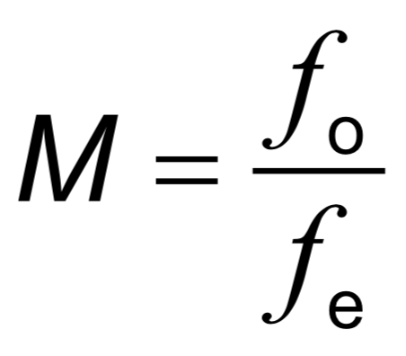 | Drawing/Diagram/Graph/Relationships

Essential idea: Total internal reflection allows light or infrared radiation to travel along a transparent fibre. However, the performance of a fibre can be degraded by dispersion and attenuation effects.
C.3 – Fibre optics
Nature of science:
Applied science: Advances in communication links using fibre optics have led to a global network of optical fibres that has transformed global communications by voice, video and data. (1.2)

Understandings:  • Structure of optic fibres  • Step-index fibres and graded-index fibres  • Total internal reflection and critical angle  • Waveguide and material dispersion in optic fibres  • Attenuation and the decibel (dB) scale  Applications and skills:  • Solving problems involving total internal reflection and critical angle in the context of fibre optics  • Describing how waveguide and material dispersion can lead to attenuation and how this can be accounted for  • Solving problems involving attenuation  • Describing the advantages of fibre optics over twisted pair and coaxial cables  Guidance:  • Quantitative descriptions of attenuation are required and include attenuation per unit length  • The term waveguide dispersion will be used in examinations. Waveguide dispersion is sometimes known as modal dispersion.  Data booklet reference:  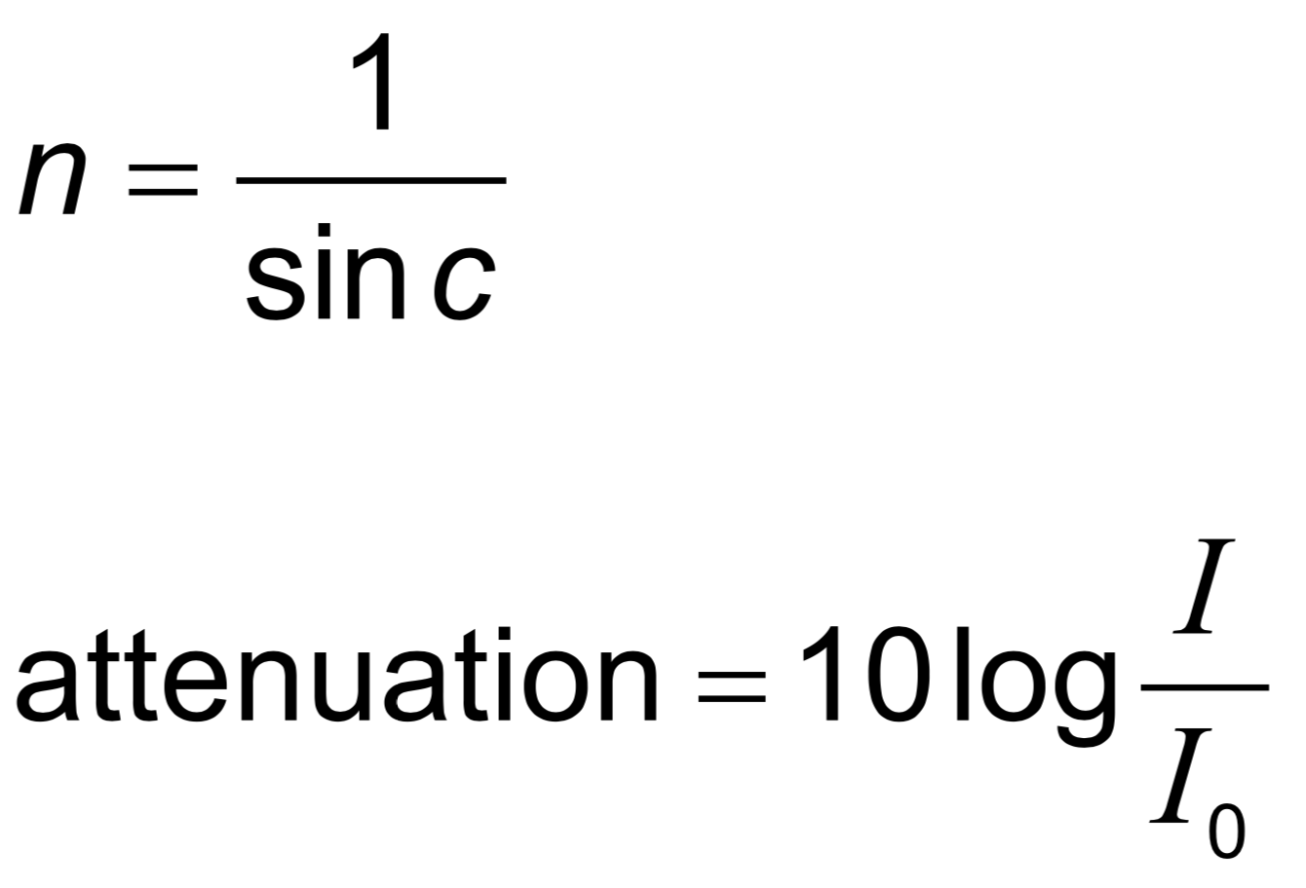 | Drawing/Diagram/Graph/Relationships

Essential idea: The body can be imaged using radiation generated from both outside and inside. Imaging has enabled medical practitioners to improve diagnosis with fewer invasive procedures.
C.4 – Medical imaging (AHL)
Nature of science:
Risk analysis: The doctor’s role is to minimize patient risk in medical diagnosis and procedures based on an assessment of the overall benefit to the patient. Arguments involving probability are used in considering the attenuation of radiation transmitted through the body. (4.8)

Understandings:  • Detection and recording of X-ray images in medical contexts  • Generation and detection of ultrasound in medical contexts  • Medical imaging techniques (magnetic resonance imaging) involving nuclear magnetic resonance (NMR)  Applications and skills:  • Explaining features of X-ray imaging, including attenuation coefficient, half-value thickness, linear/mass absorption coefficients and techniques for improvements of sharpness and contrast  • Solving X-ray attenuation problems  • Solving problems involving ultrasound acoustic impedance, speed of ultrasound through tissue and air and relative intensity levels  • Explaining features of medical ultrasound techniques, including choice of frequency, use of gel and the difference between A and B scans  • Explaining the use of gradient fields in NMR  • Explaining the origin of the relaxation of proton spin and consequent emission of signal in NMR  • Discussing the advantages and disadvantages of ultrasound and NMR scanning methods, including a simple assessment of risk in these medical procedures  Guidance:  • Students will be expected to compute final beam intensity after passage through multiple layers of tissue. Only parallel plane interfaces will be treated.  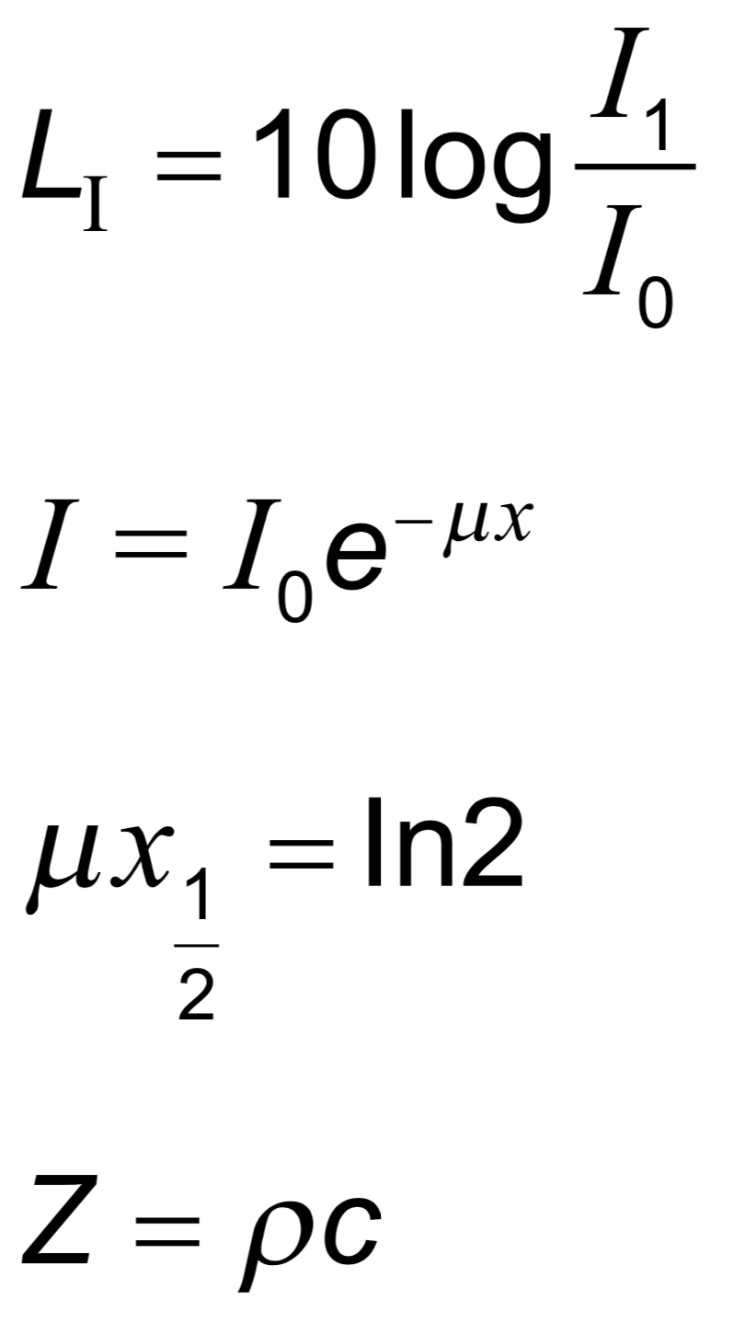  Data booklet reference: | Drawing/Diagram/Graph/Relationships

Option D: Astrophysics (15 + 10 hours)
Syllabus Dissection

Essential idea: One of the most difficult problems in astronomy is coming to terms with the vast distances between stars and galaxies and devising accurate methods for measuring them.
D.1 – Stellar quantities
Nature of science:
Reality: The systematic measurement of distance and brightness of stars and galaxies has led to an understanding of the universe on a scale that is difficult to imagine and comprehend. (1.1)

Option D: Astrophysics
Understandings:  • Objects in the universe  • The nature of stars  • Astronomical distances  • Stellar parallax and its limitations  • Luminosity and apparent brightness  Applications and skills:  • Identifying objects in the universe  • Qualitatively describing the equilibrium between pressure and gravitation in stars  • Using the astronomical unit (AU), light year (ly) and parsec (pc)  • Describing the method to determine distance to stars through stellar parallax  • Solving problems involving luminosity, apparent brightness and distance  Guidance:  • For this course, objects in the universe include planets, comets, stars (single and binary), planetary systems, constellations, stellar clusters (open and globular), nebulae, galaxies, clusters of galaxies and super clusters of galaxies  • Students are expected to have an awareness of the vast changes in distance scale from planetary systems through to super clusters of galaxies and the universe as a whole  Data booklet reference:  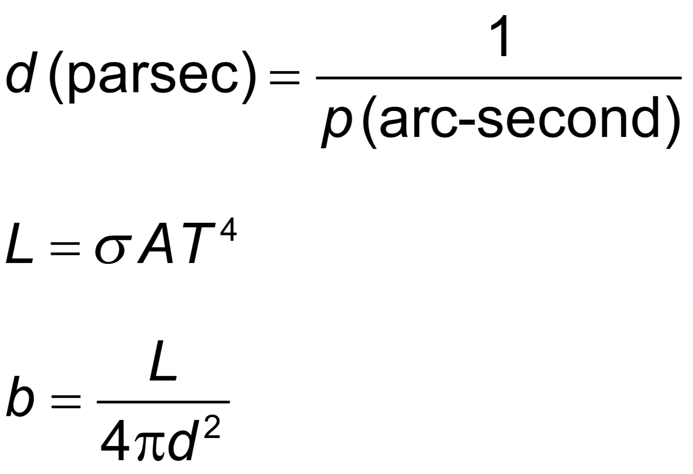 | Drawing/Diagram/Graph/Relationships

Essential idea: A simple diagram that plots the luminosity versus the surface temperature of stars reveals unusually detailed patterns that help understand the inner workings of stars. Stars follow well-defined patterns from the moment they are created out of collapsing interstellar gas, to their lives on the main sequence and to their eventual death.
D.2 – Stellar characteristics and stellar evolution
Nature of science:
Evidence: The simple light spectra of a gas on Earth can be compared to the light spectra of distant stars. This has allowed us to determine the velocity, composition and structure of stars and confirmed hypotheses about the expansion of the universe. (1.11)

Understandings:  • Stellar spectra  • Hertzsprung–Russell (HR) diagram  • Mass–luminosity relation for main sequence stars  • Cepheid variables  • Stellar evolution on HR diagrams  • Red giants, white dwarfs, neutron stars and black holes  • Chandrasekhar and Oppenheimer–Volkoff limits  Applications and skills:  • Explaining how surface temperature may be obtained from a star’s spectrum  • Explaining how the chemical composition of a star may be determined from the star’s spectrum  • Sketching and interpreting HR diagrams  • Identifying the main regions of the HR diagram and describing the main properties of stars in these regions  • Applying the mass–luminosity relation  • Describing the reason for the variation of Cepheid variables  • Determining distance using data on Cepheid variables  • Sketching and interpreting evolutionary paths of stars on an HR diagram  • Describing the evolution of stars off the main sequence  • Describing the role of mass in stellar evolution  Guidance:  • Regions of the HR diagram are restricted to the main sequence, white dwarfs, red giants, super giants and the instability strip (variable stars), as well as lines of constant radius  • HR diagrams will be labelled with luminosity on the vertical axis and temperature on the horizontal axis  • Only one specific exponent (3.5) will be used in the mass–luminosity relation  • References to electron and neutron degeneracy pressures need to be made  Data booklet reference:  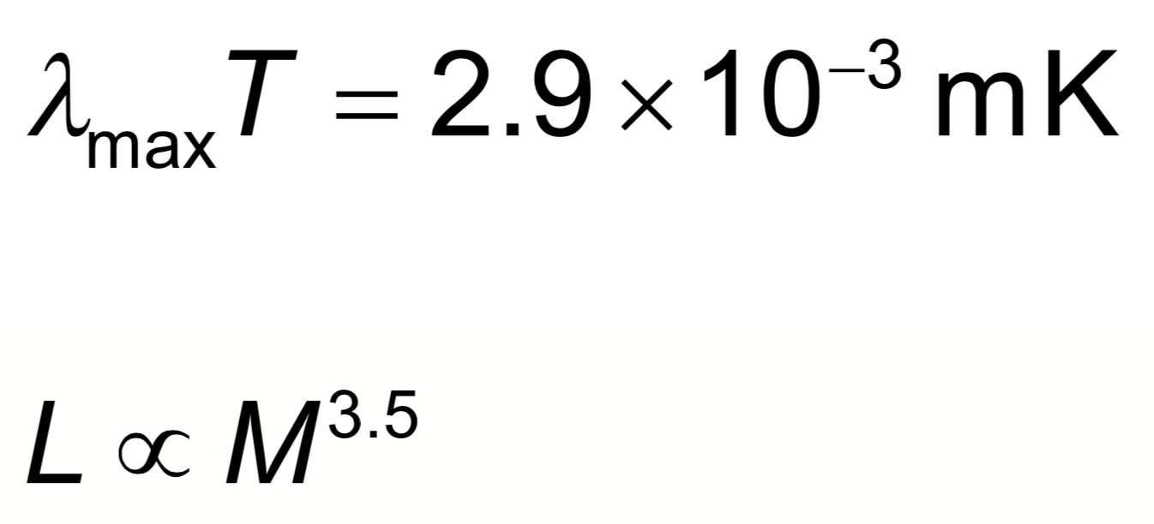 | Drawing/Diagram/Graph/Relationships
Essential idea: The Hot Big Bang model is a theory that describes the origin and expansion of the universe and is supported by extensive experimental evidence.
D.3 – Cosmology
Nature of science:
Occam’s Razor: The Big Bang model was purely speculative until it was confirmed by the discovery of the cosmic microwave background radiation. The model, while correctly describing many aspects of the universe as we observe it today, still cannot explain what happened at time zero. (2.7)

Understandings:  • The Big Bang model  • Cosmic microwave background (CMB) radiation  • Hubble’s law  • The accelerating universe and redshift (z)  • The cosmic scale factor (R)  Applications and skills:  • Describing both space and time as originating with the Big Bang  • Describing the characteristics of the CMB radiation  • Explaining how the CMB radiation is evidence for a Hot Big Bang  • Solving problems involving z, R and Hubble’s law  • Estimating the age of the universe by assuming a constant expansion rate  Guidance:  • CMB radiation will be considered to be isotropic with T 2.76K  • For CMB radiation a simple explanation in terms of the universe cooling down or distances (and hence wavelengths) being stretched out is all that is required  • A qualitative description of the role of type Ia supernovae as providing evidence for an accelerating universe is required  Data booklet reference:  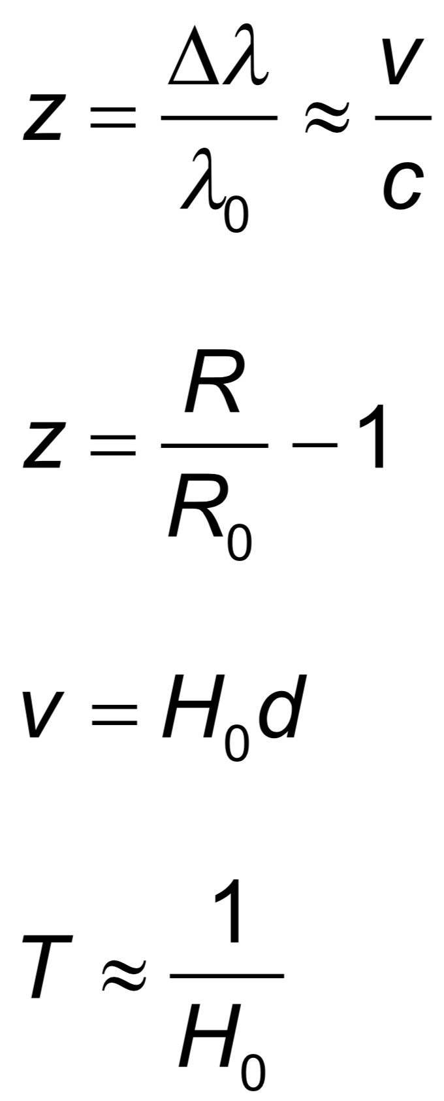 | Drawing/Diagram/Graph/Relationships

Essential idea: The laws of nuclear physics applied to nuclear fusion processes inside stars determine the production of all elements up to iron.
D.4 – Stellar processes (AHL)
Nature of science:
Observation and deduction: Observations of stellar spectra showed the existence of different elements in stars. Deductions from nuclear fusion theory were able to explain this. (1.8)

Understandings:  • The Jeans criterion  • Nuclear fusion  • Nucleosynthesis off the main sequence  • Type Ia and II supernovae  Applications and skills:  • Applying the Jeans criterion to star formation  • Describing the different types of nuclear fusion reactions taking place off the main sequence  • Applying the mass–luminosity relation to compare lifetimes on the main sequence relative to that of our Sun  • Describing the formation of elements in stars that are heavier than iron including the required increases in temperature  • Qualitatively describe the s and r processes for neutron capture  • Distinguishing between type Ia and II supernovae  Guidance:  • Only an elementary application of the Jeans criterion is required, ie collapse of an interstellar cloud may begin if M > Mj  • Students should be aware of the use of type Ia supernovae as standard candles  Data booklet reference: | Drawing/Diagram/Graph/Relationships

Essential idea: The modern field of cosmology uses advanced experimental and observational techniques to collect data with an unprecedented degree of precision and as a result very surprising and detailed conclusions about the structure of the universe have been reached.
D.5 – Further cosmology (AHL)
Nature of science:
Cognitive bias: According to everybody’s expectations the rate of expansion of the universe should be slowing down because of gravity. The detailed results from the 1998 (and subsequent) observations on distant supernovae showed that the opposite was in fact true. The accelerated expansion of the universe, whereas experimentally verified, is still an unexplained phenomenon. (3.5)

Understandings:  • The cosmological principle  • Rotation curves and the mass of galaxies  • Dark matter  • Fluctuations in the CMB  • The cosmological origin of redshift  • Critical density  • Dark energy  Applications and skills:  • Describing the cosmological principle and its role in models of the universe  • Describing rotation curves as evidence for dark matter  • Deriving rotational velocity from Newtonian gravitation  • Describing and interpreting the observed anisotropies in the CMB  • Deriving critical density from Newtonian gravitation  • Sketching and interpreting graphs showing the variation of the cosmic scale factor with time  • Describing qualitatively the cosmic scale factor in models with and without dark energy  Guidance:  • Students are expected to be able to refer to rotation curves as evidence for dark matter and must be aware of types of candidates for dark matter  • Students must be familiar with the main results of COBE, WMAP and the Planck space observatory  • Students are expected to demonstrate that the temperature of the universe varies with the cosmic scale factor as $T ∝\frac{1}{R}$  Data booklet reference:  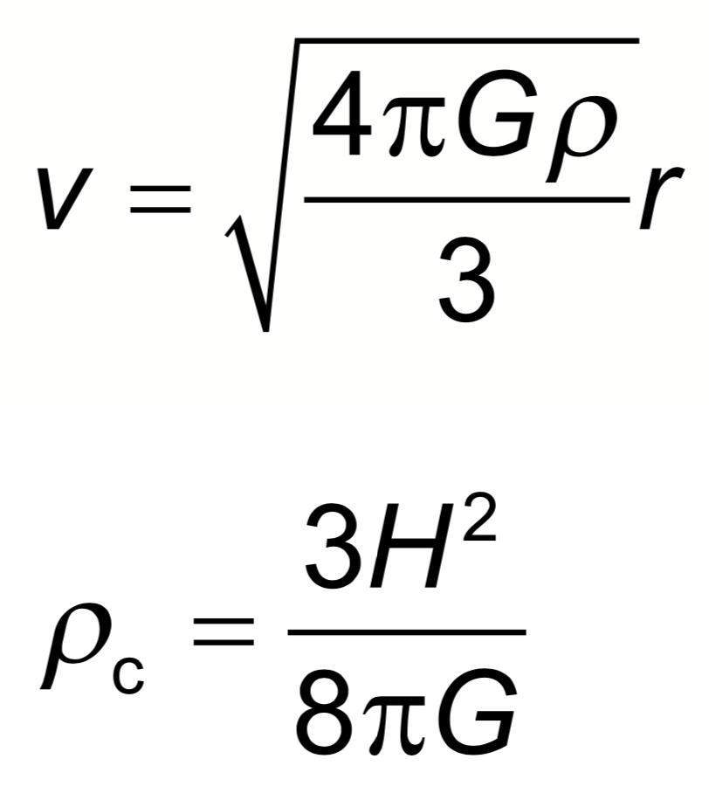 | Drawing/Diagram/Graph/Relationships

